**UNIT – I**

**1Q) Write the concepts of OOP**

**Ans:** The Concepts of OOP are

1. class
2. object
3. Data Abstraction
4. Data Encapsulation
5. Polymorphism
6. inheritance
7. Message passing /communication
8. Dynamic Binding

## Object

* It is a basic unit of OOP and represents the real life entities.
* It is an instance of class
* A typical Java program creates many objects, which as you know, interact by invoking methods. An object consists of:
  1. **State**: It is represented by attributes of an object. It also reflects the properties of an object.
  2. **Behavior**: It is represented by methods of an object. It also reflects the response of an object with other objects.
  3. **Identity**: It gives a unique name to an object and enables one object to interact with other objects.

## Example of an object: dog

1. **Class**

* Collection of object is called as a class
* A class can also be defined as a blueprint from which you can create an individual object. Class doesn't consume any space.
* A class is the way to bind data and its associated functions together. It allows the data to be hidden if necessary from the external use. When defining a class we are creating a new abstract data type that can be treated like any other built in datatype.

## Syn: Class <class_name>

**{**

**member1;**

**member2;**

**<returntype> method1([arglist])**

**{**

**Block of statements**

**}**

}

1. **Data Abstraction**

* Abstraction refers to the act of representing essential features without including the background details or explanations.
* Classes use the concept of abstraction and are defined as a list of abstract attributes such as size, weight and cost and functions to operate on these attributes. They encapsulate all the essential properties of the objects that are to be created.
* The attributes are sometimes called **data members** because they hold information. The functions that operate on these data are sometimes called **methods** or **member functions.**

1. **Data Encapsulation**

* The wrapping up of data and functions into a single unit is known as Data encapsulation.
* Data encapsulation is the most striking feature of a class. The data is not accessible to the outside world, and only those functions which are wrapped in the class can access it. These functions provide the interface between the object’s data the program. This insulation of the data from direct access by the program is called data hiding or information hiding.

1. **Polymorphism**

* Polymorphism is a combination of two Greek words called **poly** and **morphism**.
* **Poly** means **many** and **morphism** means **forms** and thus **polymorphism means many forms**.
* In object oriented programming, polymorphism refers to identically named methods that have different behavior depending on the type of object they refer.
* Polymorphism is the process of defining, a number of objects of different classes into a groupand call the methods to carry out the operation of the objects using different function calls.

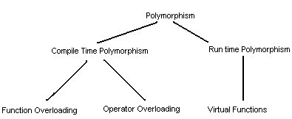

**EARLY BIDNING**

Choosing a function in normal way, during compilation time is called as **early binding** or **static binding** or **static linkage.** During compilation time, the compiler determines which function is used based on the parameters passed to the function or the function’s return type. The compiler then substitutes the correct function for each invocation. Such compiler based substitutions are called **static linkage.**

With early binding, one can achieve greater efficiency. Function calls are faster in this case because all the information necessary to call the function are hard coded.

**LATE BINDING**

Choosing functions during execution time is called the **late binding** or **dynamic binding** or **dynamic linkage.** Late binding requires some overhead Jbut provides increased power and flexibility. The late binding is implemented through virtual functions. An object of a class must be declared either as a pointer to a class or a reference to a class.

1. **Inheritance**

* Inheritance is the process by which objects of one class acquire the properties of object of another class.
* It supports the concept of hierarchical classification.
* In OOP, the concept of inheritance provides the idea of reusability. This means that we can add additional features to an existing class without modifying it. This is possible by deriving a new class from the existing one. The new class will have the combined features of both the classes.

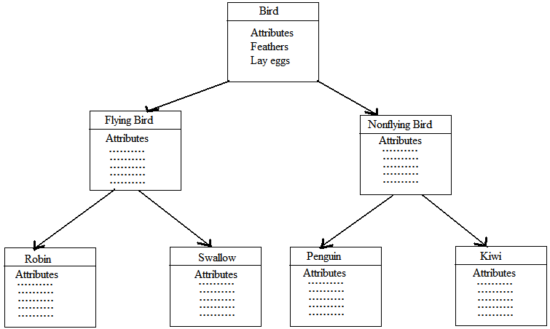

Inheritances are of different types. They are -

1. Single inheritance
2. Multiple inheritance
3. Multilevel inheritance
4. Hybrid inheritance
5. Hierarchical inheritance
6. Multi-path Inheritance
7. **Single inheritance**

A class which can able to create another class, it is called as single inheritance. It means the features or properties of a base class can be given to a child class. A parent class is also called as a base class and a child class is also called as a derived class.

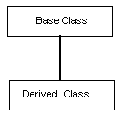

1. **Multiple inheritances**

A class which inherits the features or properties from different parent classes, it is called as multiple Inheritances.

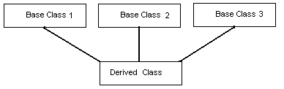

1. **Multi-level inheritance**

A class which can be created in sequence that means a class can contains feature or properties of grant base and parent classes. It is called as multi-level inheritance. A class is derived from another derived class it is called multi-level inheritance.

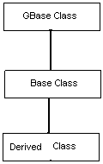

1. **Hierarchical inheritance**

The base class includes all the features that are common to the subclasses. Subclasses can be constructed by inheriting the properties of the base class. A subclass can serve as a base class for the lower level classes and so on. This process is called hierarchical inheritance.

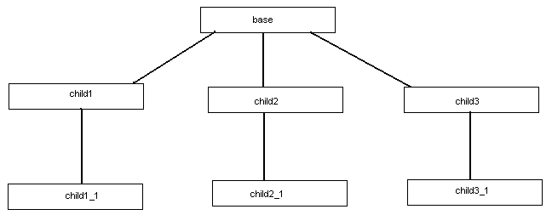

1. **Hybrid Inheritance**

A class which inherits the features or properties from the combination of multiple parent classes, it is called as hybrid Inheritance. It means hybrid inheritance is the combination of multi-level and multiple inheritances.

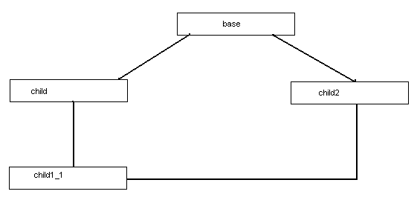

1. **Multipath inheritance**
   * Multipath inheritance in C++ is derivation of a class from other derived classes, which are derived from the same base class. In this type of inheritance, there involves other inheritance like multiple, multilevel, hierarchical etc.
   * It is famously known as diamond problem in computer programming.

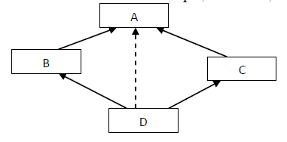

* Here, class D is derived from derived classes B & C directly and from class A indirectly. (hierarchical and multiple)
* Both derived classes inherits the features of base class. Hence when we derive a new class by inheriting features form these two classes derived from the same base class, then same features from the first base is inherited to the finally derived class from two paths. This cause ambiguity in accessing first base class members.

1. **Message passing**

An object-oriented program consists of a set of objects that communicate with each other. The process of programming is an object-oriented language, therefore, involves the following basic steps

* Creating classes that define objects and their behavior
* Creating objects from class definitions
* Establishing communication among objects

1. **Dynamic Binding**

Binding refers to the tie-up of a procedure call to the addressed code to be executed in response to the call. Dynamic binding means that the code associated with a given procedure call is not known until its call at run-time. A function call associated with a polymorphic reference depends on the dynamic type of that reference.

**2Q) Problems in Procedure Oriented Approach**

**Ans:**

* The program code is harder to write when Procedural Programming is employed
* The Procedural code is often not reusable, which may pose the need to recreate the code if is needed to use in another application
* Difficult to relate with real-world objects
* The importance is given to the operation rather than the data, which might pose issues in some data-sensitive cases
* The data is exposed to the whole program, making it not so much security friendly

**3Q) Write the Features of OOP?**

**Ans:**

1. Emphasis is on data rather than procedure.
2. Programs are divided into what are known as objects.
3. Data structures are designed such that they characterize the objects.
4. Functions that operate on the data of an object are tied together in the data structure
5. Data is hidden and cannot be accessed by external functions.
6. Objects may communicate with each other through functions.
7. New data and functions can be easily added whenever necessary
8. Follows bottom-up approach in program design

**HISTORY OF JAVA**

* **In 1990** Sun Microsystems decided to develop special software that could be used to manipulate consumer electronic devices. A team of Sun Microsystems programmers headed by **James Gosling** was formed to undertake this task.
* Java is a general-purpose object oriented programming language developed by **sun Microsystems of USA in 1991**, **it was Originally called OAK** by James Gosling and his team. The team, known as **Green Project team** by Sun, demonstrated the application of their new language to control a list of home appliances using a hand-held device with a tiny touch sensitive screen.
* Java was designed for the development of software for consumer electronic devices like TVs, VCRs, toasters and such other electronic machines. This goal had a strong impact on the development team to make the language simple, portable and highly reliable.
* The java team which included **Patrick Naughton** discovered that the existing languages like C and C++ had limitations in terms of both reliability and portability. However, they modeled their new language Java on C and C++ but removed a number of features of C and C++ that were considered as sources of problems and thus made java a really simple, reliable, portable and powerful language.
* **In 1993 the WWW** appeared on the internet and transformed the text-based internet into a graphical-rich environment. The Green Project team came up with the idea of developing web applets using the new language that could run on all types of computer connected to internet.
* **In 1994** the team developed a web browser called **“Hot Java”** to located and run applet programs on internet.
* **In 1995 Oak was renamed “Java”,** due to some legal problems. Java is just a name and is not an acronym. Many popular companies including Netscape and Microsoft announced their support to java.

**Features / Buzzwords of JAVA**

Java is OOP language which is having the following features. They are –

1. Object Oriented
2. Simple
3. Platform Independent and Portable
4. Robust and secured
5. Architectural Neutral
6. Multithreaded
7. Distributed
8. Dynamic and Extensible
9. **Object-Oriented**

* It is a true-object oriented language.
* Almost everything in java is an object.
* OOPS is so integral to java that you must understand its basic principles, such as Data Encapsulation, Polymorphism and inheritance.

1. **Simple**

* Java was designed to be easy for the professional programming to learn and use effectively.
* If you already understand the basic concepts of OOP, learning java will be even easier.
* Java inherits the C/C++ syntax and many of OO features of C++.

1. **Platform Independent and Portable**

* Java is platform independent because it is different from other languages like C, C++, etc. which are compiled into platform specific machines while Java is a write once, run anywhere language.
* A platform is the hardware or software environment in which a program runs. There are two types of platforms software-based and hardware-based.
* The Java platform differs from most other platforms in the sense that it is a software-based platform that runs on the top of other hardware-based platforms. It has two components:

1. Runtime Environment
2. API(Application Programming Interface)

* Java code can be run on multiple platforms, **for example,** Windows, Linux, Sun Solaris, Mac/OS, etc. Java code is compiled by the compiler and converted into bytecode. This bytecode is a platform-independent code because it can be run on multiple platforms, i.e., **Write Once and Run Anywhere(WORA).**

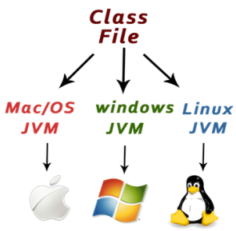

1. **Robust and Secured**

Robust simply means strong. Java is robust because:

* It uses strong memory management.
* There is a lack of pointers that avoids security problems.
* There is automatic garbage collection in java which runs on the Java Virtual Machine to get rid of objects which are not being used by a Java application anymore.
* There are exception handling and the type checking mechanism in Java.

1. **Architecture-neutral**

* Java is architecture neutral because there are no implementation dependent features, for example, the size of primitive types is fixed.
* In C programming, int data type occupies 2 bytes of memory for 32-bit architecture and 4 bytes of memory for 64-bit architecture. However, it occupies 4 bytes of memory for both 32 and 64-bit architectures in Java.

1. **High-performance**

* Java is faster than other traditional interpreted programming languages because Java bytecode is "close" to native code.
* It is still a little bit slower than a compiled language (e.g., C++).
* Java is aninterpreted language that is why it is slower than compiled languages,

**e.g.,** C, C++, etc.

1. **Multi-threaded**

* Multi-thread means handling multiple tasks simultaneously. Java supports multi-threaded programming. This means that we need not wait for the application to finish one task before beginning another.
* The main advantage of multi-threading is that it doesn't occupy memory for each thread. It shares a common memory area.
* Threads are important for multi-media, Web applications, etc.

1. **Distributed**

* Java is distributed because it facilitates users to create distributed applications in Java. It has the ability to share both data and programs.
* RMI and EJB are used for creating distributed applications. This feature of Java makes us able to access files by calling the methods from any machine on the internet.

1. **Dynamic and Extensible**

* Java is a dynamic language.
* Java is capable of dynamically linking in new class libraries, methods and objects.
* Java programs support functions written in other languages, such as C and C++. These functions are known as native methods.
* Native methods are linked dynamically at runtime. Java supports dynamic compilation and automatic memory management

**JVM**

It is:

1. **A specification** where working of Java Virtual Machine is specified. But implementation provider is independent to choose the algorithm. Its implementation has been provided by Oracle and other companies.
2. **An implementation** Its implementation is known as JRE (Java Runtime Environment).
3. **Runtime Instance** Whenever you write java command on the command prompt to run the java class, an instance of JVM is created.

* The JVM performs following operation:
* Loads code
* Verifies code
* Executes code
* Provides runtime environment
* JVM provides definitions for the:
* Memory area
* Class file format
* Register set
* Garbage-collected heap
* Fatal error reporting etc.

**JAVA TOKENS**

A Punctuation marks, cammas, semi-colons, characters etc., is called as java tokens. Java contains different types of tokens. They are

1. Identifiers
2. Keywords
3. Operators
4. Data types
5. Strings
6. Special Symbols
7. **Identifiers**

An identifier is nothing but a function name or variable name. A variable is nothing but a space in a memory where values can be constantly changed. To define identifiers the following rules to be followed. They are

* The first character of identifier name should always begin with alphabet.
* In between identifier name there should not be any special symbol except underscore
* Keywords should not be defined as identifier.
* Duplicate identifiers cannot be defined.

1. **Keywords:**

The words which are already existed in java language, they are known as keywords. These are also called as **reserve words**. Java contains 48 keywords.

**Eg**:

|  |  |  |  |  |  |
| --- | --- | --- | --- | --- | --- |
| Abstract | Assert | Boolean | Break | Byte | Case |
| Catch | Char | Class | Const | Continue | Default |
| Do | Double | Else | Enum | Extends | Final |
| Finally | Float | For | Goto | If | Implements |
| Import | Instanceof | Int | Interface | Long | Native |
| Package | Private | Protected | Public | Return | Short |
| Static | Strictfp | Super | Switch | Synchronized | This |
| Throw | Throws | Transient | Try | Void | Volatile |
| While | True | False | Null |  |  |

1. **Operators:**

An operator is nothing but symbols which are used to operate the operands. Java support different types of operators. They are

1. Arithmetic operators
2. Relational / Comparison operators
3. Logical Operators
4. Assignment Operators
5. Bitwise Logical Operators
6. Unary operators
7. Ternary Operators

**Arithmetic Operators**

The arithmetic operators are used to perform arithmetic calculations such as addition, subtraction, multiplication and division. The arithmetic operators are

|  |  |  |
| --- | --- | --- |
| **Operator** | **Meaning** | **Examples** |
| + | Addition | A=10,B=20,C=A+B=>30 |
| - | Subtraction | A=10,B=20,C=A-B=>-10 |
| * | Multiplication | A=10,B=20,C=A*B=>200 |
| / | Division | A=10,B=2,C=A/B=>5 |
| % | Modulus | A=10,B=3,C=A%B=>1 |

**Relational / Comparison Operators**

The relational or comparison operators are used to compare different operands. The relational operators are

|  |  |  |
| --- | --- | --- |
| **Operator** | **Meaning** | **Examples** |
| > | Greater than | A=10,b=5,a>b =>0(true) |
| < | Less than | A=10,b=5,A<b =>-1(false) |
| >= | Greater than equals to | A=10,b=5,a>=b =>0(true) |
| <= | Less than equals to | A=10,b=5,A<=b =>-1(false) |
| == | equals to | A=10,b=5,A= =b =>-1(false) |
| != | not equals to | A=10,b=5,A!=b =>0(true) |

**Logical Operators**

The logical operators are used to combine two or more expressions into one. The logical operators are

|  |  |
| --- | --- |
| **Operator** | **Meaning** |
| && | And |
| || | Or |
| ! | Not |

**Eg for AND:**

|  |  |  |  |
| --- | --- | --- | --- |
| **Exp1** | **&&** | **Exp2** | **Result** |
| T | && | T | T |
| T | && | F | F |
| F | && | T | F |
| F | && | F | F |

**Eg for OR:**

|  |  |  |  |
| --- | --- | --- | --- |
| **Exp1** | **||** | **Exp2** | **Result** |
| T | || | T | T |
| T | || | F | F |
| F | || | T | F |
| F | || | F | F |

**Eg for NOT:**

|  |  |
| --- | --- |
| **!Exp** | **Result** |
| T | F |
| F | T |

**Bitwise Logical Operators**

The Bitwise logical operators are used to perform bit calculations. The Bitwise logical operators are

|  |  |
| --- | --- |
| **Operator** | **Meaning** |
| >> | Right Shift |
| << | Left Shift |
| ~ | Complement |
| ^ | XOR |

**Unary Operator**

The Unary operators are used to perform unary calculations. The unary operators are incrementation and decrementation. The incrementation can be post incrementation or pre-incrementation and the decrementation can be post decrementation or pre-decrementation.

|  |  |  |
| --- | --- | --- |
| **Operator** | **Meaning** | **Examples** |
| ++ | Incrementation | A=5  A++ =>6 |
| -- | Decrementation | A=5  A-- =>4 |

**Assignment Operators**

The assignment operators are used to assign R.H.S value to L.H.S either before calculation or after calculation.

|  |  |  |
| --- | --- | --- |
| **Operator** | **Meaning** | **Examples** |
| = | Assigns RHS value to LHS | **a=10** |
| += | Assigns RHS value to LHS after addition | **a=10**  **a+=3=>13**  **or**  **a=a+3=>13** |
| -= | Assigns RHS value to LHS after subtraction | **a=10**  **a - =3=>7**  **or**  **a=a - 3=>7** |
| *= | Assigns RHS value to LHS after multiplication | **a=10**  **a*=3=>30**  **or**  **a=a*3=>30** |
| /= | Assigns RHS value to LHS after Division | **a=10**  **a/=2=>5**  **or**  **a=a/2=>5** |
| %= | Assigns RHS value to LHS after modulus | **a=10**  **a%=3=>1**  **or**  **a=a%3=>1** |

**Ternary Operators**

It is also called as conditional operator. The conditional operators are used to execute true statement only when the condition is true otherwise it executes false statement.

|  |  |
| --- | --- |
| **Operator** | **Meaning** |
| ? | Question mark |
| : | colon |

**Datatypes:**

Data types specify the different sizes and values that can be stored in the variable. Java is a statically typed programming language. It means all variables must be declared before its use. That is why we need to declare variable’s type and name. There are two types of data types in Java:

* 1. Primitive Data type
  2. Non-primitive Data type

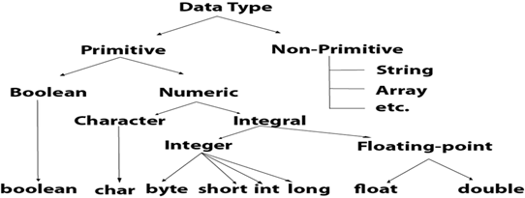

1. **Primitive Data type:**

Java supports eight primitive data types: byte, short, int, long, float, double, char and Boolean. These eight data types are further classified into four groups.

* 1. Integer
  2. Rational Numbers (Floating point)
  3. Characters
  4. Boolean

**Integer Type:**

Integer is the whole number without any fractional point. It can hold whole numbers such as 196, -52, 4036, etc. Java supports four different types of integers, they are:

|  |  |  |  |
| --- | --- | --- | --- |
| **Name** | **Types** | **Range** | **Memory** |
| Integer | Byte | -128 to 127 | 1 byte |
| Short | -32,768 to 32767 | 2 byte |
| Int | -2147,483,648 to +2147,483,647 | 4 byte |
| Long | -9223,372,036,854,755,808  To  9223,372,036,854,755,807 | 8 bytes |

**Rational Numbers:**

It is used to hold whole numbers containing fractional part such as 36.74, or -23.95. There are two types of floating point storage in java. These are:

|  |  |  |  |
| --- | --- | --- | --- |
| **Name** | **Types** | **Range** | **Memory** |
| Rational | Float | 3.4*10-38 to 3.4*10+37 | 4 bytes |
| Double | 1.7 * 10-308 to 1.7 * 10+307 | 8 bytes |

**Characters**

It is used to store character constants in memory. Java provides a character data type called char whose type consumes a size of two bytes but can hold only a single character. Its value-range lies between '\u0000' (or 0) to '\uffff' (or 65,535 inclusive)

|  |  |  |  |
| --- | --- | --- | --- |
| **Name** | **Types** | **Range** | **Memory** |
| Character | Char | 0 to 216-1 | 2 bytes |
| String | The String data type is used to store a sequence of characters. String values must be surrounded by double quotes |  |

**Conditional/Boolean**

Boolean type is used to test a particular condition during program execution. Boolean variables can take either true or false and is denoted by the keyword boolean and usually consumes one byte of storage.

|  |  |  |  |
| --- | --- | --- | --- |
| **Name** | **Types** | **Range** | **Memory** |
| Boolean | Boolean | True or false | 1 bit |

### Non-primitive data type

### Non-primitive data types are created by programmer. It is also called as 'Reference Variables' or 'Object reference' because it refers a memory location where data is stored.

### Non Primitive data types - Data types in Java - Edureka

1. **Strings:**

String is a sequence of characters. But in Java, a string is an object that represents a sequence of characters. The *java.lang.String* class is used to create a string object. If you wish to know more about Java Strings, you can refer to this article on [Strings in Java](https://www.edureka.co/blog/java-string/).

1. **Arrays:**

Arrays in Java are homogeneous data structures implemented in Java as objects. Arrays store one or more values of a specific data type and provide indexed access to store the same. A specific element in an array is accessed by its index. If you wish to learn Arrays in detail, then kindly check out this article on [Java Arrays](https://www.edureka.co/blog/java-array/).

1. **Classes:**

A [class in Java](https://www.edureka.co/blog/java-tutorial/#obj) is a blueprint which includes all your data.  A class contains fields(variables) and methods to describe the behavior of an object.

1. **Interface:**

Like a class, an *interface* can have methods and variables, but the methods declared in [*interface*](https://www.edureka.co/blog/java-collections/#interface) are by default abstract

1. **Special Symbols:**

The symbols which have special functionality are called as special symbols.

|  |  |
| --- | --- |
| **Symbol** | **Meaning** |
| [ ] | Square Brackets |
| ( ) | Parantheses |
| { } | Braces |
| “ “ | Double Quotes |
| ‘ ‘ | Single Quotes |
| ; | Semi-colon |

**Constants**

Constant is also called as Literals. A constant is a fixed value that will not be changed ever during the execution of the program. Once the programmer defines a value to a constant, it remains same through the entire program. C supports several types of constants.

1. **Integer constants:** An integer constant is a sequence of numerical digits. There are three types of integer constants.
   * + 1. **Decimal integer constant** consists of a set of digits 0 to 9. Decimal integers may be either positive or negative.

**Eg: 1234, 3443, -1233, 0, 92929**

* + - 1. An **octal integer constant** consists of any combination of digits from the set 0 to 7 with a leading 0. Octal values have no sign.

**Eg: 034 , 027, 0736**

* + - 1. **Hexadecimal integer constant** consist a set of digits 0 to 9 and alphabets A to F to represent the values 10 to 15. Each hexa value begins with 0x.

**Eg: 0x20, 0xF5, 0xabf6**

1. **Real Constants:**

The numbers containing fractional parts are called as **real constants**. To represent fixed floating point values, we use real constants. These numbers are represented with a decimal value containing a decimal point. A real constant may be either positive or negative

**Eg: 3.1428, 0.000455, -1.346**

A real number may also be expressed in exponential notation.

**Eg: 2.1565e2**

E2 means multiply the number 102

Then the above value becomes 215.65

1. **Character constants:**

A character constant contains single character enclosed within a pair of single quotation marks. The character may be an alphabet, digit or any symbol.

**Eg: ‘C’, ‘8’,’$’**

1. **String constants:**

A string constant is a sequence of characters enclosed between a pair of double quotation marks. A string constant may contain alphabets, digits, any symbols and white spaces.

**Eg: “hello world” “1234” “@#$&^”**

1. **Backslash Character constants:**

Java supports backslash character constants that are used to format the output presented to the user. These characters are also called as **escape sequence characters**.

|  |  |
| --- | --- |
| **Code** | **Meaning** |
| \n | New line |
| \a | Beep sound |
| \t | Horizontal Tab space |
| \’ | Single quotes |
| \” | Double Quotes |
| \\ | Backslash |
| \0 | Null value |
| \r | Carriage return |

**Structure of Java program**

The Structure of java program is divided into 6 sections. They are –

* + - * 1. **Documentation Section**

The documentation section comprises a set of comment lines giving the name of the program, the author and other details, which the programmer would like to refer to at a later stage. The comment about a program can be written in 3 different levels.

* + - 1. // Single line comment
      2. /* Paragraph Comment */
      3. /** Documentation Comment */
    1. **Package Statement**

The first statement allowed in a java file is a package statement. This statement declares a package name and informs the compiler that the classes defined here belong to this package.  **The package statement is optional**

**Syn: package pack_name;**

* + 1. **Import statements**

The import statement is very similar to the #include statement in C. This statement instructs the interpreter to load the class contained in the package.

**Syn:import pack_name;**

* + 1. **Interface Statements**

An interface is like a class but includes a group of method declarations. This is also an optional section and is used only when we wish to implement the multiple inheritance features in the program. Interface is a new concept in java.

* + 1. **Class Definitions**

A java program may contain multiple class definitions. Classes are the primary and essential elements of a java program. These classes are used to map the objects of real-world problems. The number of classes used depends on the complexity of the problem.

* + 1. **Main Method Class**

Since every java stand-alone program requires a main method as its starting point, this class is the essential part of a java program. A simple java program may contain only this part. The main method creates objects of various classes and establishes communications between them.

# Java Naming Convention

* Java naming convention is a rule to follow as you decide what to name your identifiers such as class, package, variable, constant, method, etc. But, it is not forced to follow. So, it is known as convention not rule. These conventions are suggested by several Java communities such as Sun Microsystems and Netscape.
* All the classes, interfaces, packages, methods and fields of Java programming language are given according to the Java naming convention. If you fail to follow these conventions, it may generate confusion or erroneous code.

## Advantage

1. By using standard Java naming conventions, you make your code easier to read for yourself and other programmers.

## Naming Conventions of the Different Identifiers

The following table shows the popular conventions used for the different identifiers.

|  |  |  |
| --- | --- | --- |
| **Identifiers** | **Naming Rules** | **Examples** |
| Class | 1. It should start with the uppercase letter. 2. It should be a noun such as Color, Button, System, Thread, etc. 3. Use appropriate words, instead of acronyms. | public class **Employee** { //code snippet } |
| Interface | * + - * 1. It should start with the uppercase letter.         2. It should be an adjective such as Runnable, Remote, ActionListener.         3. Use appropriate words, instead of acronyms. | interface **Printable** { //code snippet } |
| Method | 1. It should start with lowercase letter. It should be a verb such as main(), print(), println(). 2. If the name contains multiple words, start it with a lowercase letter followed by an uppercase letter | class Employee { void **draw()** {  //code snippet  } } |
| Variable | 1. It should start with a lowercase letter 2. It should not start with the special characters 3. If the name contains multiple words, start it with the lowercase letter followed by an uppercase 4. Avoid using one-character variables such as x, y, z. | class Employee { int **id**; //code snippet } |
| Package | 1. It should be a lowercase letter such as java, lang. 2. If the name contains multiple words, it should be separated by dots (.) such as java.util, java.lang. | package **com.javatpoint;** class Employee { //code snippet } |
| Constant | 1. It should be in uppercase letters 2. If the name contains multiple words, it should be separated by an underscore. 3. It may contain digits but not as the first letter. | class Employee { static final int **MIN_AGE** = 18; //code snippet } |

**Variable**

**A variable** is nothing but a space in a memory where values can be constantly changed during the program execution.

The declaration of a variable tells the compiler what the variable name is, the data type of the variable and scope of the variable. Each variable must be declared before to use it.

**Syntax**: datatype var1,var2..;

**Eg:** intrno;

float height;

char gender;

**Initializing a variable:**

Initializing a variable is nothing but assigning a value to the variable. This can be done in two ways.

* 1. By using an assignment statement
  2. By using a read statement.

**Syn -1**: datytypevar=value;

**Eg: int a=10;**

Float height=160.75f;

char gender=’M’;

**Eg 2: int a;**

**float b;**

DataInputStream dis=new DataInputStream(System.in);

a=Integer.parseInt(dis.readLine());

b=Float.parseFloat(dis.readLine());

**Scope of a Variable:**

The area of the program where the variable is accessible is called “Scope” of the variable. The scope of a variable defines the life span of that variable. A variable may have any of the scopes like block scope, method scope (local scope), class scope (global scope) etc.,

**Types of Variables**

Java variables are classified into the following types:

1. Instance Variables

2. Class Variables

3. Local Variables.

**Instance Variables:**

Instance variables are the variables that are declared inside the class. These variables are created when the objects are instantiated and associated with the objects. They take different values for each object.

**Class variables:**

Class variables are the variables that are declared inside the class as static variables. These variables are global to entire class thus they are common to entire set of objects created for that class.

**Local Variables:**

Local variables are the variables that we declared and used inside the methods of a class. These variables are not accessible outside the class in which they are declared. Local variables can also be declared inside the blocks which are defined between a pair of opening and closing braces i.e., {}. The variables which are declared inside a block will be accessible only that block.

**Eg:**

public class sample

{

static String nm; // class / Global variable

intrno; // Instance variables

public void display()

{

int fees=7000; // local variables

System.out.println(“Rno =” + rno);

System.out.println(“Name =” + nm);

System.out.println(“Fees =” + fees);

}

public static void main(String[] args) throws Exception

{ Sampleob=new sample();

sample.nm=”raju”;

ob.rno=1001;

ob.display();

}

}

**Displaying data in java using System class**

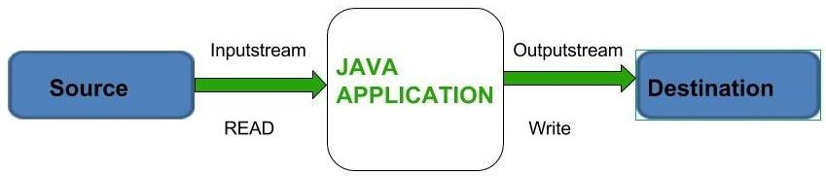[Java](https://www.geeksforgeeks.org/java/) brings various Streams with its I/O package that helps the user to perform all the **input-output operations.** These streams support all the types of **objects, data- types, characters, files etc** to fully execute the I/O operations.

Before exploring various input and output streams. Let look at **3 standard or default streams** that Java has to provide which are also most common in use:

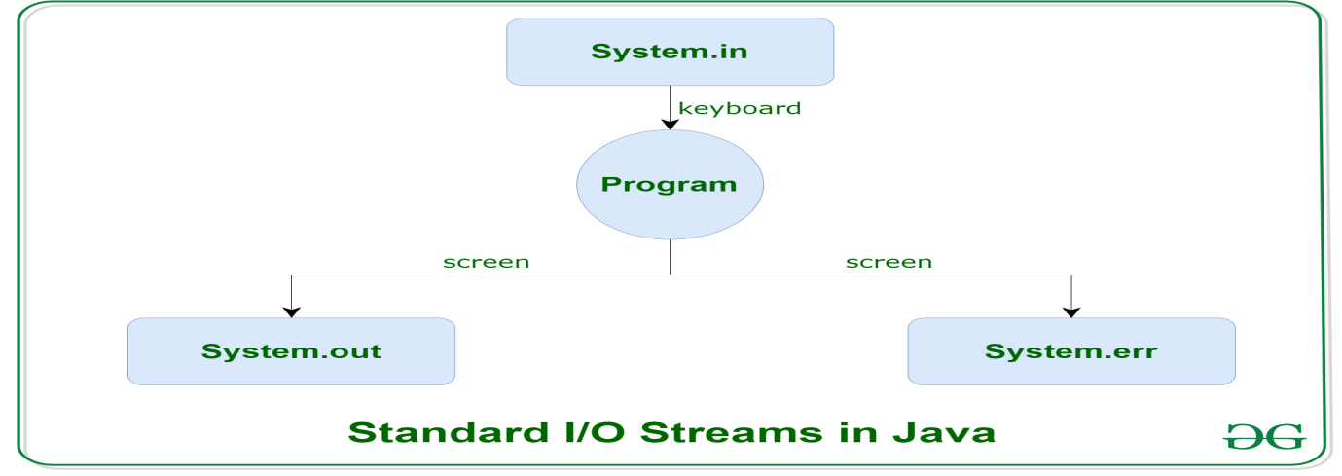

1. [**System.in:**](https://www.geeksforgeeks.org/java-lang-system-class-java/)

This is the **standard input stream** that is used to read characters from the keyboard or any other standard input device.

1. [**System.out:**](https://www.geeksforgeeks.org/java-lang-system-class-java/)
   * This is the **standard output stream** that is used to produce the result of a program on an output device like the computerscreen.
   * Here is a list of the various print functions that we use to outputstatements:
2. [**print():**](https://www.geeksforgeeks.org/difference-between-print-and-println-in-java/)

This method in Java is used to display a text on the console. This text is passed as the parameter to this method in the form of String. This method prints the text on the console and the cursor remains at the end of the text at the console. The next printing takes place from just here.

class Demo_print

**Syn: System.out.print( Parameter ) ;**

{

public static void main(String[]args)

{ System.out.print("S. Muthahar ! ");

System.out.print(" Cell No: 9885545889 ");

System.out.print(" Kadapa!");}

}

**Output:** S. Muthahar ! Cell No: 9885545889 Kadapa!

1. [**println():**](https://www.geeksforgeeks.org/difference-between-print-and-println-in-java/)

This method in Java is also used to display a text on the console. It prints the text on the console and the cursor moves to the start of the next line at the console. The next printing takes place from the next line.

**Syn: System.out.println( Parameter ) ;**

### // Java code to illustrate println()

class Demo_print

{

public static void main(String[] args)

{System.out.println("S. Muthahar ! ");

System.out.println(" Cell No: 9885545889 ");

}

}

**Output:** S. Muthahar !

Cell No: 9885545889

1. [**printf():**](https://www.geeksforgeeks.org/formatted-output-in-java/)

This is the easiest of all methods as this is similar to printf in C. Note that System.out.print() and System.out.println() take a single argument, but printf() may take multiple arguments. This is used to format the output in Java.

**Syn:**

**System.out.printf(“<Message><format_Controls><escape sequences>”+arg1+arg2.. ) ;**

### Eg: // A Java program to demonstrate working of printf() in Java

class JavaFormatter1

{

public static void main(String args[])

{

int x = 100;

System.out.printf("Printing simple integer: x = %d\n", x);

System.out.printf("Formatted with precison: PI = %.2f\n", Math.PI);

float n = 5.2f;

System.out.printf("Formatted to specific width: n = %.4f\n",n);

n =2324435.3f;

System.out.printf(“Formatted to right margin: n = %20.4f\n",n);

}

}

### Output:

Printing simple integer: x = 100

Formatted with precison: PI = 3.14

Formatted to specific width: n = 5.2000

Formatted to right margin: n = 2324435.2500

1. [**System.err**](https://www.geeksforgeeks.org/java-lang-system-class-java/)
   * This is the **standard error stream** that is used to output all the error data that a program might throw, on a computer screen or any standard outputdevice.
   * This stream also uses all the 3 above-mentioned functions to output the error data:
2. print()
3. println()
4. printf()

# Reading input in Java

# There are several ways to get input from the user in Java. You can to get input by using Scanner object and DataInputStream object.

### Scanner class:

* + Scanner class in Java is found in the java.util package.
  + Java provides various ways to read input from the keyboard, the java.util.Scanner class is one of them.
  + The Java Scanner class breaks the input into tokens using a delimiter which is whitespace by default.
  + It provides many methods to read and parse various primitive values.
  + The Java Scanner class is widely used to parse text for strings and primitive types using a regular expression.
  + It is the simplest way to get input in java.
  + By the help of Scanner in Java, we can get input from the user in primitive types such as int, long, double, byte, float, short, etc
  + The Java Scanner class provides nextXXX() methods to return the type of value such as nextInt(), nextByte(), nextShort(), next(), nextLine(), nextDouble(), nextFloat(), nextBoolean(), etc. To get a single character from the scanner, you can call next().charAt(0) method which returns a single character.

**Syntax:** Scanner ob=newScanner(System.in);

|  |  |  |
| --- | --- | --- |
| **S.No.** | **Method** | **Description** |
| 1 | Next() | It is used to get the next complete token from the scanner which is in use |
| 2 | nextBoolean() | It reads a Boolean value from the user |
| 3 | nextByte() | It reads a byte value from the user |
| 4. | nextDouble() | It reads a double value from the user |
| 5 | nextFloat() | It reads a float value from the user |
| 6 | nextInt() | It reads a integer value from the user |
| 7 | nextLine() | It reads a string value from the user |
| 8 | nextLong() | It reads a long value from the user |
| 9 | nextShort() | It reads a short value from the user |
| 10 | hasNext() | It returns true if this canner has another token  in its input. |
| 11 | hasNextBoolean() | It is used to check if the next token in this scanner’s input can be interpreted as a Boolean using the nextBoolean() method or not |
| 12 | hasNextByte() | It is used to check if the next token in this scanner's input can be interpreted as a Byte using the nextBigDecimal() method or not |
| 13 | hasNextDouble() | It is used to check if the next token in this scanner's input can be interpreted as a BigDecimal using the nextByte() method or not. |
| 14 | hasNextFloat() | It is used to check if the next token in this scanner's input can be interpreted as a Float using the nextFloat() method or not. |
| 15 | hasNextInt() | It is used to check if the next token in this scanner's input can be interpreted as an int using the nextInt() method or not. |
| 16 | hasNextLong() | It is used to check if the next token in this scanner's input can be interpreted as a Long using the nextLong() method or not. |

**Command Line Arguments**

* The java command-line argument is an argument i.e. passed at the time of running the java program.
* The arguments passed from the console can be received in the java program and it can be used as an input.
* So, it provides a convenient way to check the behavior of the program for the different values. You can pass **N** numbers of arguments from the command prompt.
* The arguments whatever we passed they can be stored in String array and they can act as string
* The user can enter command-line arguments when invoking the application. When running the java program from java command, the arguments are provided after the name of the class separated by space.

// **Program to demonstrate command line arguments.**

class sample

{

public static void main(String[] args)

{

int a,b;

a=Integer.parseInt(args[0]);

b=Integer.parseInt(args[1]);

System.out.println(“Sum =” + (a+b));

}

}

C:\>javac sample.java

C:\> java sample 10 20

Sum = 30

**Unit – 2**

**Control Statements**

The control statements that java supports are

1. Conditional Statements
2. Loops
3. Unconditional Statements

**Conditional Statements**

The conditional statements are used to control the flow of execution of statements of a program. Java support different types of conditional statements. They are

1. Simple if
2. If..else
3. If..else if
4. Neste if
5. Switch
6. Ternary operators
   1. **Simple if**:

This conditional statement executes true statements only when the condition is true, otherwise the, if statement will be terminated.

**Syntax:**

if (expression)

{

Statement1;

Statement2;

}

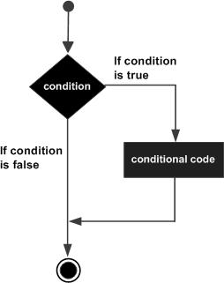

* 1. **if .. else:**

This conditional statement can execute true statements only when the condition is true otherwise it executes false statements.

**Syntax:** if( expression )

{

statement1;

statement2;

}

else

{

statement1;

statement2;

}

* + - * **if .. else if:**

It is also called as a branching statement or Ladder statement. This conditional statement executes statements based on its respective condition.

**Syntax:** if( expression1 )

{

statement1;

statement2;

}

else if(expression2)

{

statement1;

statement2;

}

else

{

statement1;

statement2;

}

* + - * **Nested if:**

A if statement which can execute within a if statement it is called as nested if conditional statement. It is also called as a multi-level branching statement.

**Syntax:** if(exp1)

{

if(exp1.1)

{ statement1;

statement2;

}

else

if(exp1.2)

{ statement1;

statement2;

}

}

else

if(exp2)

{

if(exp2.1)

{ statement1;

statement2;

}

else

if(exp1.2)

{ statement1;

statement2;

}

}

* + - * **Switch:**

It is also called as branching statement. This conditional statement is very similar to if..else if conditional statement. The execution of switch statement is very faster than if..else if conditional statement.

**Syntax:** switch(exp)

{

case constant1 : statement1;

statement2;

break;

case constant2: statement1;

statement2;

break;

case constant3: statement1;

statement2;

break;

default: statement;

}

* **Ternary Operators**

It is also as conditional operators. These conditional operators are used to execute a true statement only when the condition is true otherwise it executes a false statement

**Syn:** exp ? True statement: false statement;

**Loops**

Executing a statement or group of statements for a repeated number of times, it is called as a loop. Java language contains different types of loops. They are –

1. for .. loop
2. while .. loop
3. do .. while loop

**for ..loop:**

A simple for loop is the same as [C](https://www.javatpoint.com/c-programming-language-tutorial)/[C++](https://www.javatpoint.com/cpp-tutorial). We can initialize the [variable](https://www.javatpoint.com/java-variables), check condition and increment/decrement value. It consists of four parts:

1. **Initialization**:

It is the initial condition which is executed once when the loop starts. Here, we can initialize the variable, or we can use an already initialized variable. It is an optional condition.

1. **Condition**:

It is the second condition which is executed each time to test the condition of the loop. It continues execution until the condition is false. It must return boolean value either true or false. It is an optional condition.

1. **Statement**:

The statement of the loop is executed each time until the second condition is false.

1. **Increment/Decrement**:

It increments or decrements the variable value, it is an optional condition.

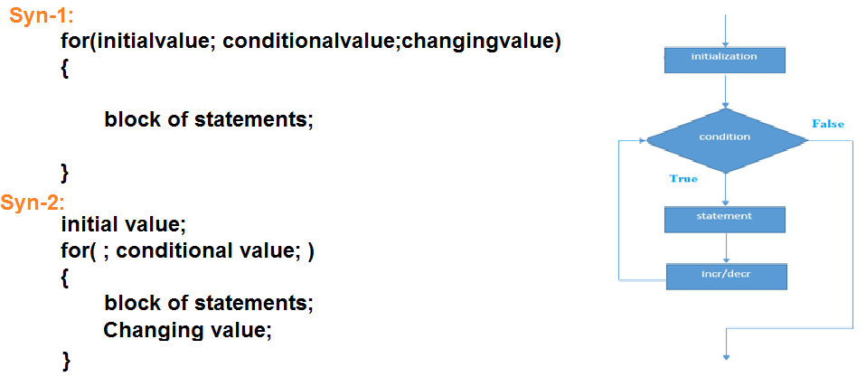

**Nested for..loop:**

A for..loop which can execute with in a for .. loop itself, such loop can be called as nested for .. loop. The execution of this loop always depends on the conditional value of the loop.

**Syntax:** for(initialvalue; conditionalvalue; changing value)

{

for(initialvalue ; conditional value; changing value)

{ statement1;

statement2;

}

}

**While ..loop:**

It is also called as a conditional loop. In this loop a statement or group of statements can be executed for a repeated number of times only when the condition is true otherwise the loop will be terminated.

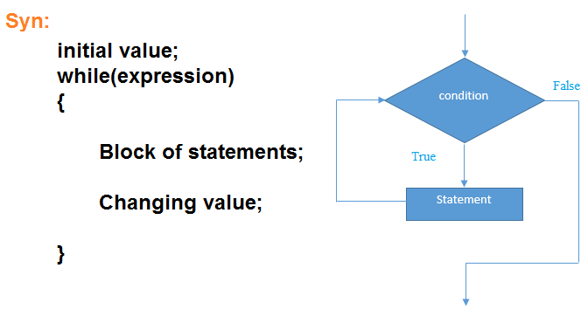

**do ..while loop:**

The *do-while loop* is used to iterate a part of the program several times. If the number of iteration is not fixed and you must have to execute the loop at least once, it is recommended to use do-while loop. The *do-while loop* is executed at least once because condition is checked after loop body.

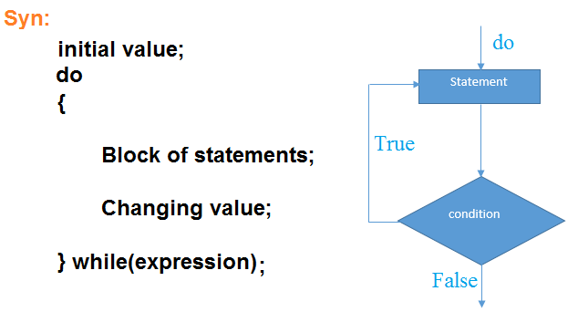

**Jumping Statements**

When the programmer wants to skip some portion of the loop body, they can use jumping statements. Jumping statements are used to transfer the control from one part of the code to another part of the code. Java supports the following statements as jumping statements which can be used to control the flow of the control.

break

continue

**break:**

* When a break statement is encountered inside a loop, the loop is immediately terminated and the program control resumes at the next statement following the loop.
* The Java break statement is used to break loop or [switch](https://www.javatpoint.com/java-switch) statement. It breaks the current flow of the program at specified condition. In case of inner loop, it breaks only inner loop.
* We can use Java break statement in all types of loops such as [for loop](https://www.javatpoint.com/java-for-loop), [while loop](https://www.javatpoint.com/java-while-loop) and [do-while loop](https://www.javatpoint.com/java-do-while-loop).

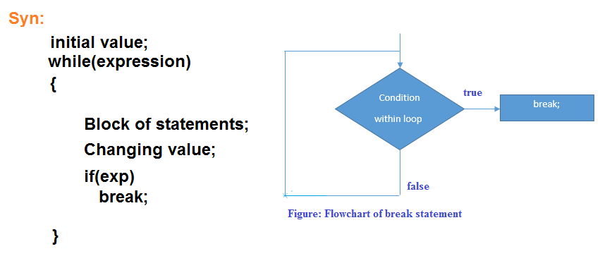

**Eg:** public class BreakEg

{

public static void main(String[] args)

{

for(int i=1;i<=10;i++)

{

if(i==5)

break;

System.out.print(i);

}

}

}

**Output:**

1 2 3 4

**Continue:**

* The continue statement is used in loop control structure when you need to jump to the next iteration of the loop immediately. It can be used with for loop or while loop.
* The Java *continue statement* is used to continue the loop. It continues the current flow of the program and skips the remaining code at the specified condition. In case of an inner loop, it continues the inner loop only.
* We can use Java continue statement in all types of loops such as for loop, while loop and do-while loop.

**Syntax:** while(exp)

{ Statement1;

Statement2

if(exp)

continue;

}

**Array**

* An array is a collection of similar type of elements which have a contiguous memorylocation.
* **Java array** is an object which contains elements of a similar data type. Additionally, the elements of an array are stored in a contiguous memory location. It is a data structure where we store similar elements. We can store only a fixed set of elements in a Javaarray.
* Array in Java is index-based, the first element of the array is stored at the 0th index, 2nd element is stored on 1st index and soon.
* Unlike C/C++, we can get the length of the array using the **length member**. In C/C++, we need to use the sizeofoperator.
* In Java, array is an object of a dynamically generatedclass.
* We can store primitive values or objects in an array in Java.
* Moreover, Java provides the feature of anonymous arrays which is not available inC/C++.

## Types of Array

1. **Single DimensionArray**
2. **Double DimensionArray**
3. **Multi-Dimension Array**
4. **JaggedArray**

**Single Dimension Array:**

* An array which contains only one row and it can have set of columns it is called as single dimension array.
* It is also called as single subscripted value array or one dimensional array.
* Array position always starts from zero
* Each section of an array is called as an element.

**Syntax:** datatype [ ]array_name=new datatype[size];

(or)

datatypearray_name[ ]=new [size]datatype;

**Eg:** int a[ ]= new int[5];

int b[]=new [5]int;

* Whenever memory is allocated for array variable, JVM assigns an attribute called**length** to it.

int x[ ] = new int[10] ;

System.out.println(x.length ); => 10

**Initialization of an 1-D array:**

You can initialize an array in java either one by one or using a single statement as follows –

**Initialization of values in an array** –

Eg: - 1. int a[4]= { 10,20,30,40 };

a[0] = 10

a[1] = 20

a[2] = 30

a[3] = 40

The number of values between braces { } cannot be larger than the number of elements that we declare for the array between square brackets [ ].If you omit the size of the array, an array just big enough to hold the initialization is created. Therefore, if you write −

2. int x[] ={10,20,30,40,50,60};

x[0] = 10

x[1] = 20

x[2] = 30

x[3] = 40

x[4] = 50

x[5] = 60

**Double Dimension Array**

* An array which contains 2 rows and 2 columns, it is called as double dimension array.
* It is also called as double sub-scripted value array.

**Syntax:** datatype var[][]=new datatype[rs][cs];

**eg:-** int a[ ][ ]=new int[3][3];

a[0][0] a[0][1] a[0][2]

a[1][0] a[1][1] a[1][2]

a[2][0] a[2][1] a[2][2]

While allocating memory to a two dimensional array, number of row specification is must but not column specification.

**eg:-** int a=new int[4][4];

int b[ ]=new int[3][4];

System.out.println(b.length);

System.out.println(b[1].length);

int c[ ][ ] = new int [3][ ] ;

c[0]=new int [2];

c[1]=new int[3];

c[2]=new int[4];

**Initialization of an 2D array:**

**Eg-1:**int a[][]={{10,20,30},{40,50,60},{70,80,90}};

a[0][0] a[0][1] a[0][2]

**10 20 30**

a[0][0] a[0][1] a[0][2]

**40 50 60**

a[0][0] a[0][1] a[0][2]

**70 80 90**

**Eg:2 int x[][]={{1},{2,3},{4,5,6},{7,8,9,10}}**

x[0][0]

**1**

x[1][0] x[1][1]

**2 3**

x[2][0] x[2][1] x[2][2]

**4 5 6**

x[2][0] x[2][1] x[2][2] x[2][3]

**7 8 9 10**

**Multi-Dimensional array:**

Three dimensional arrays are also called as space array. In this space rows and columns are taken. Three dimensional array will require three subscripts i.e., three pairs of square brackets

**Declaration of three dimensional array**

Similar to one and two dimensional arrays most be declared being used. The declaration statements tells the compiler the name of the array, the data type of each element in the array and size of each dimension. A three dimensional array is declared as

**Syn:** datatype array_name[][][]=new type[size][size][size];

**Initialization of 3D array:**

You can initialize a three dimensional array in similar way like a two dimensional array

**Eg:**

Int a[2][3][4]={{ { 1,2,3,4}, {5,6,7,8}, {9,10,11,12}},

{ {13,14,15,16},{17,18,19,20},{21,22,23,24}}

};

**Accessing elements of the 3D array:**

Three dimensional arrays contains three subscripts, we will use three for loops to access the elements

**For example**, arr contains 3*2*4=24 elements.

The arr[3][2][4] can be represented as shown below

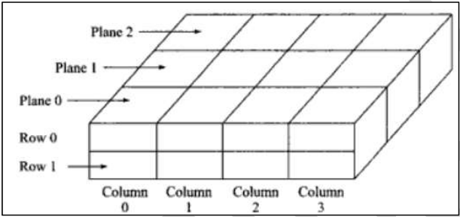

**Eg:** class ThreeD

{

public static void main(String[] args)

{

int a[][][]=new int[2][2][2];

int i,j,k,m=1;

for(i=0;i<2;i++)

{

for(j=0;j<2;j++)

{

for(k=0;k<2;k++)

{

a[i][j][k]=m;

m++;

}

}

}

System.out.println("Three Dimensional Array \n");

for(i=0;i<2;i++)

{

for(j=0;j<2;j++)

{

for(k=0;k<2;k++)

{

System.out.print(a[i][j][k]+" ");

}

System.out.println();

}

System.out.println();

}

}

}

**Jagged Array**

A double dimension array can be represented jagged array that means an array which can have any number of rows and each row of array can have different columns.

**Syn:** datatype array_name[ ][ ]=new datatype[rs][ ];

array_name[index]=new datatype[cs];

**Eg:** int x[][]={{1},{2,3},{4,5,6},{7,8,9,10}}

x[0][0]

1

x[1][0] x[1][1]

2 3

x[2][0] x[2][1] x[2][2]

4 5 6

x[2][0] x[2][1] x[2][2] x[2][3]

7 8 9 10

**String class**

* String is a sequence of characters but it’s not a primitive type.
* When we create a string in java, it actually creates an object of type String.
* String is **immutable object** which means that it cannot be changed once it is created.
* String is the only class where operator overloading is supported in java. We can concat two strings using + operator.
* Java provides two useful classes for String manipulation –[StringBuffer](https://www.journaldev.com/16827/stringbuffer-in-java) and [StringBuilder](https://www.journaldev.com/16833/java-stringbuilder).
* A Java string is not a character array and is not NULL terminated.
* It is a final class defined in **java.lang package.**

**Different Ways to Create String**

There are many ways to create a string object in java, some of the popular ones are given below.

1. **Using string literal**

This is the most common way of creating string. In this case a string literal is enclosed with double quotes.

Eg: String str = "abc";

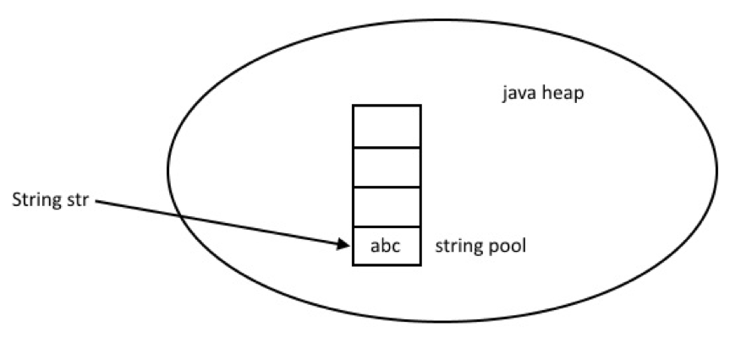

When we create a String using double quotes, JVM looks in the [String pool](https://www.journaldev.com/797/what-is-java-string-pool) to find if any other String is stored with same value. If found, it just returns the reference to that String object else it creates a new String object with given value and stores it in the String pool.

#### Using new keyword

We can create String object using new operator, just like any normal java class. There are several constructors available in String class to get String from char array, byte array, StringBuffer and StringBuilder.

**Syn:** String ob=new String();

Or

String ob=new String(“String”);

**Eg:**

String str = new String("abc");

char[] a = {'a', 'b', 'c'};

String str2 = new String(a);

**Eg:**

public class StrExample

{

public static void main(String args[])

{

String s1="java";//creating string by java string literal

char ch[]={'s','t','r','i','n','g','s'};

String s2=new String(ch);//converting char array to string

String s3=new String("example");//creating java string by new keyword

System.out.println(s1 + “ “ +s2 +” “+ s3);

}

}

**o/p:**

java strings example

**Methods:**

String s=”java in muthusoft”;

1. **charAt():** This function returns nth character from a given string.

**Eg:** s.charAt(2) => v

1. **length(**): This function returns the length of a given string.

**Eg:**s.length() => 17

1. **concat():** This function is used to combine two strings into one.

**Eg:**

s.concat(“kadapa”)

java in muthusoftkadapa

1. **trim():** This function removes trailing and leading spaces of string

**eg**: String s1=” computer “;

s1.trim() => computer

1. **replace():**

This function is used to replace the mis-spelled character with new character.

**Eg:** String s=”lwinkle”

s.replace(‘lw’,’tw’ ) => twinkle

1. **indexOf():** This function returns the position of the given character.

**Eg:** String s=”java in muthusoft”

s.indexOf(“java”) => 0

1. **lastIndexOf():** This function returns the last index position of given string.

**Eg:** String s=”java in muthusoft”

s.lastIndexOf(“in”) => 5

1. **substring():** This function gives substring starting from nth character

**Eg:** String s=”java in muthusoft”

s.substring(5) => in muthusoft

1. **startsWith():**

This function returns Boolean expression true/false, whether a given string starts with specified charaters or not.

**Eg:** String s=”java in muthusoft”

s.startswith( “java”) => true

1. **endsWith():**

This function returns Boolean expression true/false, whether a given string ends with specified characters or not.

**Eg:** String s=”java in muthusoft”

s.endsWith(“in”) => false

1. **equals():**

This function is used to compare two strings and find whether they are exact or not. If they are exact it returns true otherwise it returns false.

**Eg:**String s1=”hello”;

String s2=”Hello”;

s1.equals(s2) => false

s1.equals(“hello”) => true

1. **equalsIgnoreCase():**

This function is used to compare two strings and find whether they are similar or not. If they are similar it returns true otherwise it returns false.

**Eg:** String s1=”hello”;

String s2=”Hello”;

s1.equalsIgnoreCase(s2) => true

1. **toLowerCase():** This function is used to convert a string into lower case

**Eg:** String s=”COMPUTER”

s.toLowerCase() => computer

1. **toUpperCase():** This function is used to convert a string into upper case.

**Eg:** String s=”computer”

s.toUpperCase() => COMPUTER

**// Program to implement string functions**

import java.io.*;

classstrtest

{

public static void main(String[] args) throws Exception

{ DataInputStream dis=new DataInputStream(System.in);

String s1=new String();

String s2=new String();

s1=dis.readLine();

s2=dis.readLine();

if(s1.equals(s2))

System.out.println("Exact Strings");

System.out.println("String in uppercase ="+s1.toUpperCase());

System.out.println("String in lowercase ="+s2.toLowerCase());

System.out.println("String combination = " + s1.concat(s2));

System.out.println("String length =" + s1.length());

System.out.println("String length =" + s1.substring(1,5));

}

}

**StringBuffer class**

* StringBuffer is similar to a String but they have lot of difference.
* String creates strings of fixed length. StringBuffer creates strings of flexible length that can be modified in terms of both length and content.
* This is similar to string class defined as final in java.lang package.
* **StringBuffer is a mutable class**. We can append data to StringBuffer or insert data into StringBuffer without reference.
* To do this StringBuffer uses 16 bytes of memory to keep track of reference.

**Syn:** StringBuffersb=new StringBuffer( );

sb.append(“java”);

sb.length( ) => 4

sb.capacity( ) => 16

sb.toString( ) => java

sb.reverse()=avaj

**StringBuffer Methods:**

1. **toString()**: This method is used to convert object into string.

**Eg:** StringBuffer sb1=new StringBffer();

sb1.append(“hello”);

sb1.toString( ).toUpperCase( ) =>HELLO

2.**append( ):** This method is used to append a string into StringBuffer object.

**Eg:** StringBuffer sb1=new StringBuffer();

sb1.append(“hello”);

**3. reverse():** This function is used to reverse a string object.

**Eg:** StringBuffer sb1=new StringBuffer();

sb1.append(“hello”);

sb1.reverse( ) =>olleh

**4. length():** This function is used to find the length of object.

**Eg:** StringBuffer sb1=new StringBuffer();

sb1.append(“hello”);

sb1.length() => 5

**6. capacity():** This function returns the capacity of stringbuffer object.

**Eg:** StringBuffer sb1=new StringBffer();

sb1.capacity() => 16

#### ****String Comparison****

We can compare String in Java on the basis of content and reference. It is used in **authentication**, **sorting**, **reference matching** (by == operator) etc.There are three ways to compare String in Java:

1. By Using equals() Method
2. By Using == Operator
3. By compareTo() Method
4. **By Using equals() Method**

* The String class equals() method compares the original content of the string. It compares values of string for equality. String class provides the following two methods:
  + **public boolean equals(Object another)** compares this string to the specified object.
  + **public boolean equalsIgnoreCase(String another)** compares this string to another string, ignoring case.

**Teststringcomparison1.java**

**class** Teststringcomparison1

{

**public** **static** **void** main(String args[])

{ String s1="Sachin";

String s2="Sachin";

String s3=**new** String("Sachin");

String s4="Saurav";

System.out.println(s1.equals(s2));//true

System.out.println(s1.equals(s3));//true

System.out.println(s1.equals(s4));//false

 }

 }

## By Using == operator

**class** Teststringcomparison3

{

**public** **static** **void** main(String args[])

{

   String s1="Sachin";

String s2="Sachin";

String s3=**new** String("Sachin");

System.out.println(s1==s2);

System.out.println(s1==s3);

}

}

1. **By Using compareTo() method**

The String class compareTo() method compares values lexicographically and returns an integer value that describes if first string is less than, equal to or greater than second string.

Suppose s1 and s2 are two String objects. If:

* **s1 == s2** : The method returns 0.
* **s1 > s2** : The method returns a positive value.
* **s1 < s2** : The method returns a negative value.

**Eg:**

**class** Teststringcomparison4

{

**public** **static** **void** main(String args[])

{   String s1="Sachin";

    String s2="Sachin";

    String s3="Ratan";

    System.out.println(s1.compareTo(s2));

System.out.println(s1.compareTo(s3));

    System.out.println(s3.compareTo(s1));

  }

}

**UNIT - III**

**Class:**

* A class is a group of objects which have common properties.
* A class can also be defined as a blueprint from which you can create an individual object. Class doesn't consume any space.
* A class is the way to bind data and its associated functions together. It allows the data to be hidden if necessary from the external use. When defining a class we are creating a new abstract data type that can be treated like any other built in data type.
* Classes are user-defined data types and behave like the built-in types of a programming language.
* A class in Java can contain **Fields, Methods, Constructors, Blocks & Nested class.** These members of class can be defined by access specifiers. They are –

1. **Private:**

The members defined under this access specifier can be accessed with in a class, functions of a class and friend functions.

1. **Protected:**

The members defined under this access specifier can be accessed with in a class, functions of a class, friend functions and in sub-classes.

1. **Public:**

The members which defined under this access specifier can be accessed anywhere in a program.

**Syn: Class <class_name>**

**{**

**member1;**

**member2;**

**<returntype> method1([arglist])**

**{**

**Block of statements;**

**}**

**<returntype> method2([arglist])**

**{**

**Block of statements;**

**}**

**<returntype> method2([arglist])**

**{**

**Block of statements;**

**}**

**:**

**:**

**}**

**Object**

* An object in Java is the physical as well as a logical entity, whereas, a class in Java is a logical entity only.
* An object is a real-world entity.
* An object is a runtime entity.
* The object is an entity which has state and behavior.
* The object is an instance of a class.
* An object has three characteristics:

1. **State:** represents the data (value) of an object.
2. **Behavior:** represents the behavior (functionality) of an object such as deposit, withdraw, etc.
3. **Identity:** An object identity is typically implemented via a unique ID. The value of the ID is not visible to the external user. However, it is used internally by the JVM to identify each object uniquely.

**Syn: class_name ob=new class_name()**

**// Program to demonstrate class and object**

**Eg-1:**

class Student

{

int id;

String name;

public static void main(String args[])

{ Student s1=new Student();//creating an object of Student

System.out.println(s1.id);//accessing member through reference variable

System.out.println(s1.name);

}

}

**Output:**

0

Null

**Eg-2:**

class Student

{ int id;

String name;

}

class TestStudent1

{

public static void main(String args[])

{ Student s1=new Student();

System.out.println(s1.id);

System.out.println(s1.name);

}

}

**Output:**

0

Null

**Anonymous object:**

* Anonymous simply means nameless. An object which has no reference is known as an anonymous object. It can be used at the time of object creation only.
* If you have to use an object only once, an anonymous object is a good approach.

**new Calculation(); //anonymous object**

**Eg:**

class Calculation

{

void fact(int n)

{ int fact=1;

for(int i=1;i<=n;i++)

fact=fact*i;

System.out.println("factorial is "+fact);

}

public static void main(String args[])

{

new Calculation().fact(5);//calling method with anonymous object

}

}

**Output:**

**Factorial is 120**

**METHODS / FUNCTIONS:**

A block of statements which performs a particular task, it is called as a function.

**Syntax:** [modifier] returntype method_name ([parameter list])

{

Statement1;

Statement2;

return value;

}

The following are four basic parts of method declaration,

returntype

Method name

list of parameters

Body of the method.

Return statement

**In the above syntax,**

* **‘return type’** specifies the type of value the method returns,**‘**
* **Method_name**’ is valid identifier.
* ‘**parameter-list**’ is enclosed in parenthesis; given to the method as input. If suppose we don’t need any input data then the declaration retains empty parenthesis.
* ‘**body of method**’ describes the operations to be performed on the data. We can overload and override methods. We can declare methods as final. By doing so, the method is redefined in a subclass we can also indicate that a method should always be redefined in a subclass using **abstract**.

**Eg:** class briefcase

{

double w, h, d;

void vol()

{ System.out.println(“Volume=” + (w*h*d)); }

}

Class demomethod

{

public static void main(String[] args)

{ briefcase b1=new briefcase();

briefcase b2=new briefcase();

b1.w=15;

b1.h=25;

b1.d=20

b2.w=4;

b2.h=7

b2.d=10

b1.vol();

b2.vol();

}

}

**PARAMETERS PASSING TO A METHOD:**

The parameters that are specified within the parenthesis of a method_call are called the actual parameters. The actual parameters are passed to a method while calling that method.

**Syntax:** obj.method(10,20,3);

The actual parameters can have the same name as that of the formal parameters. This has an advantage of reducing the number of parameter being used. It will also help the programmer in identifying how the actual parameters are manipulated in a method, as formal parameters.

**//Eg: program to demonstrate the passing of arguments to a calling function.**

class sample

{

public void vol(int a, intb,int c){

int vol=a*b*c;

System.out.println(“Volume:”+vol);

}}

classimpl

{

public static void main(String[] args)

{

int a=10,b=20,c=3;

sample ob=new sample();

ob.vol(a,b,c);

}

}

**TYPES OF PARAMETER PASSING / TYPES OF METHODS:**

There are two ways of passing arguments to method. They are,

Call-by-value

Call-by-reference

**Call-by-value:**

In call-by value, the values of actual arguments are passed to the called method. In this method, the copy of actual arguments is made and passed to the formal parameters of the called method. Doing this prevents the values of actual arguments to be changed. Therefore, in call-by-value method, changes made to the formal parameters will have no effect on the actual arguments.

**Syn: Class <class_name>**

**{**

member1;

member2;

[<modifier>][<static>] <void> method1(arg1,arg2)

{

Block of Statements;

}

[<modifier>][<static>] <void> method2(arg1,arg2)

{

Block of Statements;

}

public static void main(String[] args)

{ Class_name ob=new class_name();

Ob.method1(arg1,arg2);

Ob.method2(arg1,arg2);

**}**

**}**

**Call-by-reference:**

In call-by-reference method, an address of a variable i.e., the reference or an object is passed as a parameter to the called method. It means the calling method passes the address of a variable to the formal parameters of the called method. In call-by-reference method, the changes made to the formal parameters will affect the actual parameters.

**Syn: Class <class_name>**

**{** member1;

member2;

[<modifier>][<static>] <void> method1(class_name ob)

{ Statement1

Statement2

}

}

Class class_name2

{

public static void main(String[] args)

{ Class_name ob=new class_name();

Ob.method1(ob);

**}**

**}**

**Eg:** class Operation2

{ int data=50;

void change(Operation2 op)

{

op.data=op.data+100;//changes will be in the instance variable

}

public static void main(String args[])

{ Operation2 op=new Operation2();

System.out.println("before change "+op.data);

op.change(op);//passing object

System.out.println("after change "+op.data);

}

}

**Output**

before change 50

after change 150

**Method Overloading**

A method with identical name can be defined for any number of times, whereas its arguments or return type should be differ, it is called as **method overloading**. The invocation of methods depends on the arguments passed or based on the return type.

**Syn:**

Class class_name

{

public <returntype>method_name(arg1,arg2)

{ Statement1;

Statement2;

}

public <returntype>method_name(arg1,arg2)

{ Statement1;

Statement2;

}

**}**

**Constructors**

* A constructor is a special type of member function which is used to initialize the members of class.
* A constructor need not be called explicitly by the user, it can be called automatically when we create an object of the class.
* To create a constructor the following rules to be followed. They are

1. The constructor name should be same as that of class name.
2. A constructor may or may not have arguments.
3. A constructor should not have any return types even void also.
4. A constructor should not be defined as static

**Types of Constructors**

Constructors are of different types. They are

1. **Default constructor**
2. **Parameterized constructor.**
3. **Constructor Overloading**
4. **Copy Constructor**

**Default Constructor**:

* A constructor which doesn't have any arguments
* The default constructor is used to provide the default values to the object like 0, null, etc., depending on the type
* It can be called automatically when we create an object.

**Syn:** class class_name

{

class_name()

{

Default values to members of class;

}

}

**Eg:-1**

class Student3

{ int id;

String name;

void display()

{ System.out.println(id+" "+name); }

public static void main(String args[])

{ Student3 s1=new Student3();

Student3 s2=new Student3();

s1.display();

s2.display();

}

}

**Output:**

1. null

0 null

**Parameterized constructor:**

* A construct which can have one or more parameters can be called as parameterized constructor.
* The parameterized constructor is used to provide different values to distinct objects. However, you can provide the same values also.
* The parameterized constructor can be invoked automatically when we create an object and while creating an object we should pass arguments to a constructor.

**Syntax:** class class_name

{

class_name(arg)

{

initialize single argument;

} }

**//Eg: Program to demonstrate parameterized constructor**

import java.util.*;

class sums

{

mtable(int n)

{

for(int i=1;i<=10;i++)

System.out.println(n+"x"+i+"="+n*i);

}

public static void main(String[] args)

{ Scanner sc=new Scanner(System.in);

System.out.println("Enter N value");

int n=sc.nextInt();

mtable ob=new mtable(n);

} }

**Constructor Overloading:**

Constructor [overloading in Java](https://www.javatpoint.com/method-overloading-in-java) is a technique of having more than one constructor with different parameter lists. They are arranged in a way that each constructor performs a different task. They are differentiated by the compiler by the number of parameters in the list and their types.

**Syntax:** Class class_name

{

Class_name( ) {

Initialize the members;

}

Class_name(arg1,arg2){

Initialize the members;

}

public static void main(String[ ] args) {

statement1;

statement2;

}

.}

**// Example program to demonstrate constructor overloading**

import java.util.*;

class ParaTest

{

ParaTest(int a,int b)

{ System.out.println("A value =" + a);

System.out.println("B value =" + b);

}

ParaTest(double x,double y)

{

System.out.println("X value =" + x);

System.out.println("Y value =" + y);

}

public static void main(String[] args)

{ Scanner sc=new Scanner(System.in);

int a,b;

System.out.println("Enter two Integers");

a=sc.nextInt();

b=sc.nextInt();

ParaTest ob=new ParaTest(a,b);

System.out.println("Enter two doubles");

x=sc.nextDouble();

y=sc.nextDouble();

ParaTest ob=new ParaTest(x,y);

}

}

## Copy Constructor

* There is no copy constructor in Java. However, we can copy the values from one object to another like copy constructor in C++.
* There are many ways to copy the values of one object into another in Java. They are:
* By constructor
* By assigning the values of one object into another
* By clone() method of Object class

**Eg: // Java program to initialize the values from one object to another object.**

class Student

{

int id;

String name;

Student(int i,String n)

{ id = i;

name = n;

}

Student(Student s)

{ id = s.id;

name =s.name;

}

void display()

{ System.out.println(id+" "+name); }

public static void main(String args[])

{ Student s1 = new Student(111,"Karan");

Student s2 = new Student(s1);

s1.display();

s2.display();

}

}

**Output:**

111 Karan

111 Karan

## Difference between constructor and method

|  |  |
| --- | --- |
| **Constructor** | **Method** |
| A constructor is used to initialize the state of an object. | A method is used to expose the behavior of an object. |
| A constructor must not have a return type. | A method must have a return type. |
| The constructor is invoked implicitly. | The method is invoked explicitly. |
| The Java compiler provides a default constructor if you don't have any constructor in a class. | The method is not provided by the compiler in any case. |
| The constructor name must be same as the class name. | The method name may or may not be same as the class name. |

**Inheritance**

* This is the process of providing properties of a parent class to a child class is called as an **inheritance**. A parent class is also called as **base class / super class** and child class is also called as **derived class**.
* In java inheritance is achieved with the help of **“extends”** keyword.
* Java supports different inheritances except multiple inheritances. To perform multiple inheritances in java, JDK provides interface class.
* The idea behind inheritance in Java is that you can create new classes that are built upon existing classes. When you inherit from an existing class, you can reuse methods and fields of the parent class. Moreover, you can add new methods and fields in your current class also.
* Inheritance represents the **IS-A relationship** which is also known as a *parent-child* relationship.
* The **extends keyword** indicates that you are making a new class that derives from an existing class. The meaning of "extends" is to increase the functionality.
* In the terminology of Java, a class which is inherited is called a parent or superclass, and the new class is called child or subclass.



**Types of Inheritances:**

* 1. **Single inheritance**
* A class which can able to create another class, it is called as single inheritance. It means the features or properties of a base class can be inherited to a child class.
* **A parent class is also called as a base class** and a **child class is also called as a derived class**.
* The properties of parent class can be inherited to child class by using the keyword **extends**



**Syntax of Single Inheritance:**

class superclass-name

{

field declarations;

field declarations;

[specifier][modifier]<returntype> method1(arglist)

{

body of method;

}

.

.

}

class Subclass-name extends Superclass-name

{

field declarations;

field declarations;

[specifier][modifier]<returntype> method1(arglist)

{

body of method;

}

[specifier][modifier]<returntype> method1(arglist)

{

body of method;

}

.

.

public static void main(String[] args)

{

Code;

}}

* 1. **Multiple inheritances**

A class which inherits the properties from different parent classes, it is called as multiple inheritance. It means the properties of different base classes can be inherited to a child class



* **Multi-level inheritance**

A class which can be created in sequence that means a class can contains the properties of grand base and parent classes it is called as multi-level inheritance. A class is derived from another derived class it is called multi-level inheritance.



* **Hierarchical inheritance**

The base class includes all the properties that are common to the subclasses. Subclasses can be constructed by inheriting the properties of the base class. A subclass can serve as a base class for the lower level classes and so on. This process is called hierarchical inheritance.



* **Hybrid Inheritance**

A class which inherits the properties from the combination of multiple parent classes, it is called as hybrid Inheritance. It means hybrid inheritance is the combination of multi-level and multiple inheritances.



* **Multipath inheritance**
  + Multipath inheritance in C++ is derivation of a class from other derived classes, which are derived from the same base class. In this type of inheritance, there involves other inheritance like multiple, multilevel, hierarchical etc.
  + It is famously known as diamond problem in computer programming.



* Here, class D is derived from derived classes B & C directly and from class A indirectly. (hierarchical and multiple)
* Both derived classes inherits the features of base class. Hence when we derive a new class by inheriting features form these two classes derived from the same base class, then same features from the first base is inherited to the finally derived class from two paths. This cause ambiguity in accessing first base class members.

**Examples**

**//Eg-1: Program to demonstrate single inheritance**

class base

{

public static void stud_info()

{

System.out.println(“Rno = 1001”);

System.out.println(“Name = Sami”);

}

public static void stud_addr( )

{

System.out.println(“Dno = 18/199”)

System.out.println(“Street = G.C Street”);

System.out.println(“City = Kadapa”);

}

}

public class derived extends first

{

public static void stud_co()

{ System.out.println(“Course = Bsc”);

System.out.println(“Fees = 9000”);

}

public static void main(String[ ] args)

{ m1();

m2();

m3();

} }

**//Eg -2:**

class Employee

{ float salary=40000; }

class Programmer extends Employee

{

int bonus=10000;

public static void main(String args[])

{

Programmer p=new Programmer();

System.out.println("Programmer salary is:"+p.salary);

System.out.println("Bonus of Programmer is:"+p.bonus);

}

}

**Output:**

Programmer salary is: 40000.0

Bonus of programmer is:10000

**interface**

* An interface is a collection of **abstract methods** and **constants / final fields.**
* It cannot have any concrete methods in it.
* It tells the classes which implement the interface to do something without how to do it.
* **In java**, interfaces are used to achieve the concept of **multiple inheritance**.
* A java class cannot extend more than one class at a time, but it can implement more than one interface at a time.
* An interface is a collection of method declarations with no data and no bodies. That is, the methods of an interface are always empty that is, they are simply **method signatures**. When a class implements an interface, it must implement all of the methods declared in the interface. In this way, interfaces enforce requirements that an implementing class has methods with certain specified signatures.

**Rules:**

1. All the methods of an interface are implicitly public and abstract.
2. All the variables of an interface are implicitly public static and final
3. Interface methods should not be static or final.
4. An interface can extend one or more other interfaces.
5. An interface cannot implement another interface or class.

**Syn:**

interface <class_name>

{

variable declarations;

method declarations;

}

**Eg-1:**-**Program to implement interface class**

interface geometry

{

double pi=3.14;

public void area( );

}

public class geotest implements geometry

{

public void area( )

{

System.out.println(“Area=“+geometry.pi*(5*5));

}

public static void main(String[] args)

{

System.out.println(geometry.pi);

geotest ob= new geotest();

Ob.area();

}

}

**EXTENDING AN INTERFACE:**

Like classes, interfaces can also be extended. An interface can be sub-interfaced from other interfaces. The interface that extends another interface will inherit all the members of the super interface. The classes that implement the newly developed interface must implement both inherited methods and its own methods of the interface.

**Syn:** interface <interface_name1>

{

variable declarations;

method declarations;

}

interface<interface_name2> extends <interface_name1>

{

variable declarations;

method declarations;

}

**// Eg program to demonstrate interface**

interface base1

{

public void stud_det();

public void stud_addr();

}

interface base2 extends base1

{

public void stud_co();

}

class child implements base2

{

public void stud_det()

{

S.o.pln(“Rno=1001”);

S.o.pln(“Name=kiran”);

}

public void stud_addr()

{

S.o.pln(“Dno=12/122”);

S.o.pln(“Street=knagar”);

}

public void stud_co()

{

S.o.pln(“course=bsc”);

S.o.pln(“Fees=9000”);

}

public static void main(String[] args)

{

child ob=new child();

ob.stud_det();

ob.stud_addr();

ob.stud_co();

}

}

**IMPLEMENTING INTERFACES:**

As interface is a collection of abstract methods, we cannot give them a life. To give birth to an interface, it must be implemented by a class. **A class can implement one or more interfaces.** Through classes, we can give birth to the interfaces. The class that implements an interface will acquire all the properties of that interface.

**Syn:**

interface <interface_name1>

{

Member1;

Member2;

public <returntype> method1(arglist);

}

interface <interface_name2>

{

Members;

public <returntype> method2(arglist);

}

class <class_name> implements <interface_name1>,<interface_name2>

{

public void method1(arglist)

{

Block of statements;

}

public void method2(arglist)

{

Block of statements;

}

public static void main(String[] args)

{

Statement1;

Statement2;

}

}

**Eg:**

interface base1

{

public void stud_det();

public void stud_addr();

}

interface base2

{

public void stud_co();

}

class child implements base1,base2

{

public void stud_det()

{

S.o.pln(“Rno=1001”);

S.o.pln(“Name=kiran”);

}

public void stud_addr()

{

S.o.pln(“Dno=12/122”);

S.o.pln(“Street=knagar”);

}

public void stud_co()

{

S.o.pln(“course=bsc”);

S.o.pln(“Fees=9000”);

}

public static void main(String[] args)

{

child ob=new child();

ob.stud_det();

ob.stud_addr();

ob.stud_co();

}

}

**Method Overloading**

A method with identical name can be defined for any number of times, whereas its arguments or return type should be differ, it is called as **method overloading**. The invocation of methods depends on the arguments passed or based on the return type.

**Syn:**

Class class_name

{

public <returntype>method_name(arg1,arg2)

{ Statement1;

Statement2;

}

public <returntype>method_name(arg1,arg2)

{ Statement1;

Statement2;

}

**}**

**abstract class**

* A class that is declared as abstract is called Abstract class.
* Abstract class may have **abstract methods** or **simple / concrete methods**.
* The abstract class cannot be instantiated; that is we cannot create any objects based on an abstract class. But we can create references to an abstract class.
* Abstract classes must be extended by other concrete classes to give them life to use. We go for abstract classes when we know the implementation of some methods but do not know the implementation of some methods.
* Any class that extends an abstract class must implement all the abstract methods of the abstract super class.
* Abstract is a keyword which is also used to specify a method without body. Whenever a specification of method is known but not its implementation, we have to define a method as abstract.
* Abstract stands for “not qualified”.
* Abstract methods can reside only in abstract classes.

**Syn:**

abstract class classname

{

public abstract void method1( );

public abstract void method2( );

}

**// Example to demonstrate abstract class with abstract methods.**

abstract class arithmetic

{

public abstract void add( );

public abstract void diff( );

}

public class arithtest extends arithmetic

{

public void add( )

{

System.out.println(“Add method”);

}

public void diff( )

{

System.out.println(“diff method”);

}

public static void main(String[ ] args)

{

arithtest f=new arithtest( );

f.add( );

f.diff( );

}

}

## Abstract Method

* A method declared using the **abstract** keyword within an abstract class and does not have a definition (implementation) is called an abstract method.
* When we need just the method declaration in a super class, it can be achieved by declaring the methods as abstracts.
* Abstract method is also called subclass responsibility as it doesn't have the implementation in the super class. Therefore a subclass must override it to provide the method definition.

**Syn: abstract** return_type method_name( [ argument-list ] );

**// Example to demonstrate abstract class with abstract methods.**

abstract class arithmetic

{

public abstract void add( );

public abstract void diff( );

}

public class arithtest extends arithmetic

{

public void add( )

{

System.out.println(“Add method”);

}

public void diff( )

{

System.out.println(“diff method”);

}

public static void main(String[ ] args)

{

arithtest f=new arithtest( );

f.add( );

f.diff( );

}

}

**UNIT - IV**

**Package**

Packages are java’s way of grouping a variety of classes or interfaces together. The grouping is usually done according to functionality. In fact, packages act as containers for classes.

**Benefits of Package**

1. The classes contained in the packages of other programs can be easily reused.
2. In packages, classes can be unique compared with classes in other packages, i.e., two classes in two different packages can have the same name. They may be referred by their fully qualified name, comprising the package name and the classname.
3. Packages provide a way to “hide” classes thus preventing other programs or packages from accessing classes that are meant for internal use only.
4. Packages also provide a way for separating “design” from “coding”. First we can design classes and decide their relationships, and then we can implement the java code needed for the methods.

**Types of packages:**

1. **Built in Packages**
2. **User-defined Packages**

**Built in Packages**

These packages consist of a large number of classes which are a part of Java **API**. Some of the commonly used built-in packages are:

1. **java.lang:**

**It** Contains language support classes(e.g classed which defines primitive data types, math operations). This package is automatically imported.

1. **java.io:**

**It c**ontains classed for supporting input / output operations.

1. **java.util:**

**It c**ontains utility classes which implement data structures like Linked List, Dictionary and support ; for Date / Time operations.

1. **java.applet: It** Contains classes for creating Applets.
2. **java.awt:**

**It** contain classes for implementing the components for graphical user interfaces (like button, ;menus, etc).

1. **java.net: It c**ontain classes for supporting networking operations.

**User-defined Packages**

These are the packages that are defined by the user. The package can be created by using the package statement.

**Steps to create package**

* 1. Declare the package at the beginning of a file.

package pack_name;

* 1. Define the class that is to be put in the package and declare it public.
  2. Create a sub-directory under the directory where the main source files are stored.
  3. Store the listing as the classname.java in the sub-directory

**Eg: package package1;**

public class classA

{

public void displayA( )

{ System.out.println(“Class A”); }

public void displayB( )

{ System.out.println(“Class B”); }

}

**c:\>javac –d . classA.java**

**import package1.classA;**

class test

{

public static void main(String[ ] args)

{ classA ob=new classA( );

ob.displayA( );

ob.displayB( );

}

}

**Accessing of package**

A java system package can be accessed either using a fully qualified class name or using import statement. We generally use import statement when the package name is too long or when there are several references to a particular package. We can use the same approach for accessing user defined packages also. The below is the general form of import statement for searching a class.

import pack1[.pack2[.pack3].classname;

Here, pack1 is the name of the top level package; pack2 is the name of the package which is inside pack1 and so on. In this way we can have several packages in a package hierarchy. We should specify explicit class name finally. The statement should end with a semicolon. Multiple import statements are valid.

Import firstpack.secondpack.classname;

After defining this statement, all the members of the class one can be accessed directly using the classname or its objects directly without using the name of package. There is also one more way as shown below.

Import nameofpackage.*;

Here, **‘nameofpackage’** may represent a single package or hierarchy of packages. The ‘*’ represent that the compiler should search this entire package hierarchy when it encounters a class name. The big advantage of this is we need not use long package names in the program repeatedly and on the other hand if we follow this approach it will be very difficult to find from which package a particular member came.

Java provides many levels of protection to the variables and method to be visible within classes, subclasses and packages. Classes and packages both encapsulate the name space and scope of variables and methods. Package acts as a container for the related classes and sub packages. A class acts as a container for data and code. Because of interaction between classes and packages Java provides following four categories of visibilities for classes, members,

* + 1. Subclasses in the same package
    2. Non-subclasses in the same package
    3. Subclasses in different packages
    4. Classes that are neither in the same package nor a subclass.

There are three access specifier namely private, public and protected that provide several ways of access required by the above four categories.

**Streams**

* A Stream is a path of communication between the source of information and the destination.
* Streams can be dealt under three headings – **Input Streams**, **Output streams** and **Readers / Writers**. All of them are abstract classes. All methods of these classes throw an IOException on error conditions.
* Streams are the sequence of bits (data). There are two types of streams:

1. **Input Streams**

Input streams are used to read the data from various input devices like keyboard, file, network, etc.

1. **Output Streams**

Output streams are used to write the data to various output devices like monitor, file, network, etc.

**Types of Streams:**

There are two types of streams based on data:

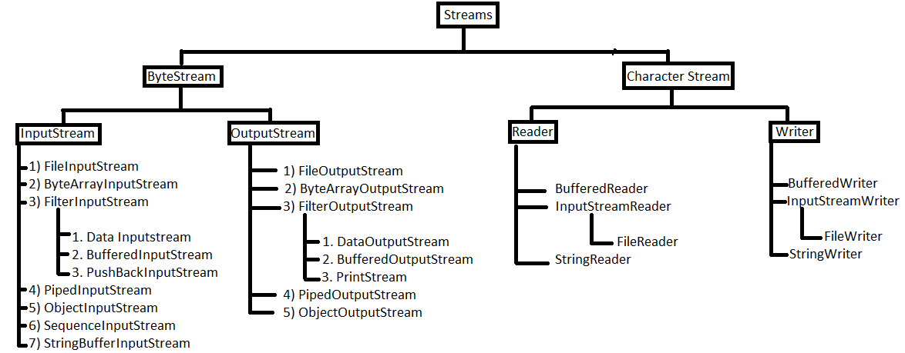

1. **Byte Stream**:

* Java byte streams are used to perform input and output of 8-bit bytes.
* Though there are many classes related to byte streams but the most frequently used classes are, **FileInputStream** and **FileOutputStream**.
* The ByteStream is classified into two types. They are

1. Input Stream
2. Output Stream

**Input Stream:**

* These are used to read byte data from various input devices.
* InputStream is an **abstract class** and it is the super class of all the input byte streams.
* List of Byte Input Streams are
  1. FileInputStream
  2. ObjectInputStream
  3. ByteArrayInputStream
  4. BufferedInputStream
  5. DataInputStream

1. **FileInputStream**

* Java FileInputStream class is a part of java.io package.
* FileInputStream obtains input bytes from a file in a file system.
* FileInputStream is used for reading streams of raw bytes such as image data.
* FileInputStream is a subclass of InputStream class.
* The FileInputStream class provides the connection to a disk file.

## Constructors

|  |  |
| --- | --- |
| **Constructors** | **Description** |
| FileInputStream(File file) | It creates a FileInputStream by opening a connection to a file. |
| FileInputStream(FileDescriptor fdobj) | Creates a FileInputStream by using the FileDescriptor object fdobj. |
| FileInputStream(String name) | Creates a FileInputStream by opening a connection to a file. |

**Methods**

|  |  |
| --- | --- |
| **Method** | **Description** |
| available() | Returns an approximation of the number of bytes that can be read from this file input stream. |
| close() | Close the input stream file and releases the system resources. |
| finalize () | Make sure that close () method of this input stream is called properly. |
| read(byte[] b) | Read the data from the given input stream in the form of an array of bytes. |
| skip(long n) | Skip or discard the n bytes of data from the input stream. |

**Eg: Program to read the data from a file.**

import java.io.*;

public class FisDemo

{  
public static void main(String args[])throws FileNotFoundException, IOException  
{

     FileInputStream fis = new FileInputStream("abc.txt");

      int i;

       System.out.println("ASCII value of the character:");

       while((i=fis.read()) != -1)

       {

System.out.print(i+" : ");

          System.out.println((char)i);  
          }  
    }  
}

**Eg-2:**

import java.io.*;

class FiTest

{

public static void main(String[] args) throws Exception

{ int v;

FileInputStream fis=new FileInputStream("c:/AdJava/DisTest.java");

while((v=fis.read())!=-1)

{

System.out.print((char)v);

}

}

}

1. **DataInputStream**

* The Java DataInputStream class enables you to read Java primitives (int, float, long etc.) from an InputStream instead of only raw bytes.
* You wrap an InputStream in a DataInputStream and then you can read Java primitives from the DataInputStream. That is why it is called *DataInputStream* - because it reads data (numbers) instead of just bytes.
* The DataInputStream is handy if the data you need to read consists of Java primitives larger than one byte each, like int, long, float, double etc. The DataInputStream expects the multi byte primitives to be written in network byte order

## Syn -1: DataInputStream dis=new DataInputStream(System.in);

## Syn -2:FileInputStream fis=new FileInputStream(“Filename”);

## DataInputStream dis=new DataInputStream(fis);

## or

## DataInputStream dis=new DataInputStream(new FileInputStream(“Filename”));

## Methods:

|  |  |
| --- | --- |
| **Methods.** | **Description** |
| read(byte [] b) | This method reads some number of bytes from the contained input stream and stores them into the buffer array *b* |
| [readBoolean()](https://www.tutorialspoint.com/java/io/datainputstream_readboolean.htm) | This method reads one input byte and returns true if that byte is nonzero, false if that byte is zero. |
| readByte() | This method reads and returns one input byte. |
| [readChar()](https://www.tutorialspoint.com/java/io/datainputstream_raedchar.htm) | This method reads two input bytes and returns a char value. |
| [readDouble()](https://www.tutorialspoint.com/java/io/datainputstream_readdouble.htm) | This method reads eight input bytes and returns a double value. |
| [readFloat()](https://www.tutorialspoint.com/java/io/datainputstream_readfloat.htm) | This method reads four input bytes and returns a float value. |
| [readInt()](https://www.tutorialspoint.com/java/io/datainputstream_readint.htm) | This method reads four input bytes and returns an int value. |
| [readLong()](https://www.tutorialspoint.com/java/io/datainputstream_readlong.htm) | This method reads eight input bytes and returns a long value. |
| [readShort()](https://www.tutorialspoint.com/java/io/datainputstream_readshort.htm) | This method reads two input bytes and returns a short value. |
| [readUnsignedByte()](https://www.tutorialspoint.com/java/io/datainputstream_readunsignedbyte.htm) | This method reads one input byte, zero-extends it to type int, and returns the result, which is therefore in the range 0 through 255. |
| [readUnsignedShort()](https://www.tutorialspoint.com/java/io/datainputstream_readunsignedshort.htm) | This method reads two input bytes and returns an int value in the range 0 through 65535. |

**Eg:**

import java.io.*;

class DisTest

{

public static void main(String[] args) throws IOException

{ int rno,fees;

String nm,co;

DataInputStream dis=new DataInputStream(System.in);

System.out.println("Enter Rno,Name,Course and Fees");

rno=Integer.parseInt(dis.readLine());

nm=dis.readLine();

co=dis.readLine();

fees=Integer.parseInt(dis.readLine());

System.out.println("Rno =" + rno);

System.out.println("Name =" + nm);

System.out.println("Course="+ co);

System.out.println("Fees ="+ fees);

}

}

**Eg:-2**

import java.io.*;

class readStud

{

public static void main(String[] args) throws Exception

{

DataInputStream dis=new DataInputStream(new FileInputStream("student.dat"));

int rno,fees;

String nm,co;

do

{

try

{ rno=dis.readInt();

nm=dis.readLine();

co=dis.readLine();

fees=dis.readInt();

System.out.println(rno +" " +nm +" "+ co +" "+ fees);

}

catch(Exception e) { break; }

}while(true);

}

}

**OutputStream**

* These are used to write byte data to various output devices.
* Output Stream is an abstract class and it is the superclass for all the output byte streams.
* List of Byte Output Streams:
  1. FileOutputStream
  2. ObjectOutputStream
  3. ByteArrayOutputStream
  4. BufferedOutputStream
  5. DataOutputStream
     1. **FileOutputStream**
* The Java FileOutputStream class, java.io.FileOutputStream, makes it possible to write a file as a stream of bytes.
* The Java FileOutputStream class is a subclass of [Java OutputStream](http://tutorials.jenkov.com/java-io/outputstream.html) meaning you can use a FileOutputStream as an OutputStream.

## Constructors

|  |  |
| --- | --- |
| **Constructor** | **Description** |
| **FileOutputStream(Filename)** | This creates a file output stream to write to the file represented by the specified *File* object. |
| **FileOutputStream(filename, boolean)** | This creates a file output stream to write to the file represented by the specified File object. |

**Methods:**

|  |  |
| --- | --- |
| **Methods** | **Description** |
| Close() | This method closes this file output stream and releases any system resources associated with this stream. |
| Finalize() | This method cleans up the connection to the file, and ensures that the close method of this file output stream is called when there are no more references to this stream. |
| write(byte[] b) | This method writes *b.length* bytes from the specified byte array to this file output stream. |
| [write(int b)](https://www.tutorialspoint.com/java/io/fileoutputstream_write.htm) | This method writes the specified byte to this file output stream. |

**Eg:**

import java.io.*;

class FiCopy

{

public static void main(String[] args) throws Exception

{ int v;

FileInputStream fis=new FileInputStream("c:/AdJava/FiTest.java");

FileOutputStream fos=new FileOutputStream("c:/AdJava/shdc.java");

while((v=fis.read())!=-1)

{ fos.write(v); }

System.out.println("File Copied...");

}

}

**DataOutputStream**

* The Java DataOutputStream class enables you to write Java primitives to OutputStream's instead of only bytes.
* You wrap an OutputStream in a DataOutputStream and then you can write primitives to it. That is why it is called a *DataOutputStream* - because you can write int, long, float and double values to the OutputStream, and not just raw bytes.
* Often you will use the Java DataOutputStream together with a [**Java DataInputStream**](http://tutorials.jenkov.com/java-io/datainputstream.html). You use the DataOutputStream to write the data to e.g. a file, and then use the DataInputStream to read the data again.
* Using the DataOutputStream and DataInputStream together is a handy way to be able to write larger primitives than bytes to an OutputStream and be able to read them in again, ensuring the right byte order is used etc.

## Syn: FileOutputStream fos=new FileOutputStream(“Filename”);

## DataOutputStream ds=new DataOutputStream(fos);

## or

## DataOutputStream ds=new DataOutputStream

## (new FileOutputStream(“filename”));

## Methods

|  |  |
| --- | --- |
| **Metods** | **Description** |
| [size()](https://www.tutorialspoint.com/java/io/dataoutputstream_size.htm) | This method returns the current value of the counter written, the number of bytes written to this data output stream so far. |
| [write(int b)](https://www.tutorialspoint.com/java/io/dataoutputstream_write.htm) | This method writes the specified byte (the low eight bits of the argument b) to the underlying output stream. |
| [writeBoolean(boolean v)](https://www.tutorialspoint.com/java/io/dataoutputstream_writeboolean.htm) | This method writes a boolean to the underlying output stream as a 1-byte value. |
| [writeByte(int v)](https://www.tutorialspoint.com/java/io/dataoutputstream_writebyte.htm) | This method writes out a byte to the underlying output stream as a 1-byte value. |
| [writeBytes(String s)](https://www.tutorialspoint.com/java/io/dataoutputstream_writebytes.htm) | This method writes out the string to the underlying output stream as a sequence of bytes. |
| [writeChar(int v)](https://www.tutorialspoint.com/java/io/dataoutputstream_writechar.htm) | This method writes a char to the underlying output stream as a 2-byte value, high byte first. |
| [writeDouble(double v)](https://www.tutorialspoint.com/java/io/dataoutputstream_writedouble.htm) | This method converts the double argument to a long using the double To Long Bits method in class Double, and then writes that long value to the underlying output stream as an 8-byte quantity, high byte first. |
| [writeFloat(float v)](https://www.tutorialspoint.com/java/io/dataoutputstream_writefloat.htm) | This method converts the float argument to an int using the float To Int Bits method in class Float, and then writes that int value to the underlying output stream as a 4-byte quantity, high byte first. |
| [writeInt(int v)](https://www.tutorialspoint.com/java/io/dataoutputstream_writeint.htm) | This method writes an int to the underlying output stream as four bytes, high byte first. |
| [writeLong(long v)](https://www.tutorialspoint.com/java/io/dataoutputstream_writelong.htm) | This method writes a long to the underlying output stream as eight bytes, high byte first. |
| [writeShort(int v)](https://www.tutorialspoint.com/java/io/dataoutputstream_writeshort.htm) | This method writes a short to the underlying output stream as two bytes, high byte first. |

**Eg:**

import java.io.*;

class StudTest

{

public static void main(String[] args) throws Exception

{ FileOutputStream fos=new FileOutputStream("student.dat");

DataOutputStream ds=new DataOutputStream(fos);

DataInputStream dis=new DataInputStream(System.in);

int rno,fees;

String nm,co;

char ch='y';

do

{

System.out.println("Enter Rno,Name,Course and Fees");

rno=Integer.parseInt(dis.readLine());

nm=dis.readLine();

co=dis.readLine();

fees=Integer.parseInt(dis.readLine());

ds.writeInt(rno);

ds.writeBytes(nm+"\n");

ds.writeBytes(co+"\n");

ds.writeInt(fees);

System.out.println("Do you want to add another record [y/n]:");

ch=(char)System.in.read();

System.in.skip(2);

}while (ch=='y');

dis.close();

ds.close();

fos.close();

}}

1. **Character Stream**:

* Java **Character** streams are used to perform input and output for 16-bit unicode.
* Though there are many classes related to character streams but the most frequently used classes are, **FileReader** and **FileWriter**. Though internally FileReader uses FileInputStream and FileWriter uses FileOutputStream but here the major difference is that FileReader reads two bytes at a time and FileWriter writes two bytes at a time.
* The Character stream is classified into 2 types. They are

1. **Reader**

* [Java](https://www.javatpoint.com/java-tutorial) Reader is an [abstract class](https://www.javatpoint.com/abstract-class-in-java) for reading character [streams](https://www.javatpoint.com/java-8-stream).
* The only methods that a subclass must implement are read(char[], int, int) and close().
* Most subclasses, however, will [override](https://www.javatpoint.com/method-overriding-in-java) some of the methods to provide higher efficiency, additional functionality, or both.
* Some of the implementation [class](https://www.javatpoint.com/object-class)es are

[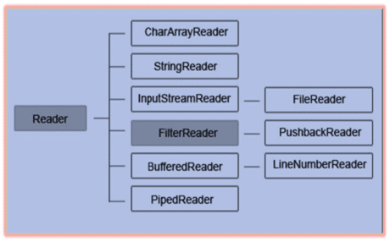](https://intellipaat.com/mediaFiles/2015/11/mj7.png)

1. **Writer**

* It is an [abstract](https://www.javatpoint.com/abstract-class-in-java) class for writing to character streams.
* The methods that a subclass must implement are write(char[], int, int), flush(), and close(). Most subclasses will override some of the methods defined here to provide higher efficiency, functionality or both.
* List of Character Output Stream

[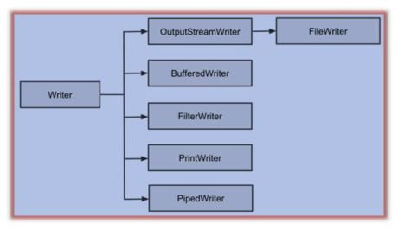](https://intellipaat.com/mediaFiles/2015/11/mj8.jpg)

**Character Stream**

* Character Stream Classes are used to read characters from the source and write **characters** to destination.
* Java **Character** streams are used to perform input and output for 16-bit unicode. Though there are many classes related to character streams but the most frequently used classes are, **FileReader** and **FileWriter**. Though internally FileReader uses FileInputStream and FileWriter uses FileOutputStream but here the major difference is that FileReader reads two bytes at a time and FileWriter writes two bytes at a time.
* There are two kinds of Character Stream classes –

1. **Reader classes**

* Reader class is a base class of all the classes that are used to read characters from a file, memory or console.
* Reader is an abstract class and hence we can't instantiate it but we can use its subclasses for reading characters from the input stream.
* The Reader class contains number of sub-classes. They are
  + 1. BufferedReader
    2. StringReader
    3. PipedReader
    4. CharArrayReader
    5. FileReader

**Methods:**

|  |  |
| --- | --- |
| **Methods** | **Description** |
| **read()** | This method reads a characters from the input stream. |
| **close()** | This method closes this output stream and also frees any system resources connected with it. |

* + 1. **FileReader**
* The Java FileReader class, java.io.FileReader makes it possible to read the contents of a file as a stream of characters.
* It works much like the [**FileInputStream**](http://tutorials.jenkov.com/java-io/fileinputstream.html) except the FileInputStream reads bytes, whereas the FileReader reads characters.
* The FileReader is intended to read text, in other words. One character may correspond to one or more bytes depending on the character encoding scheme.
* The Java FileReader is a subclass of the [Java Reader](http://tutorials.jenkov.com/java-io/reader.html) class,

**Constructor**

|  |  |
| --- | --- |
| **Constructor** | **Description** |
| FileReader(String file) | It gets filename in [string](https://www.javatpoint.com/java-string). It opens the given file in read mode. If file doesn't exist, it throws FileNotFoundException. |
| FileReader(File file) | It gets filename in [file](https://www.javatpoint.com/java-file-class) instance. It opens the given file in read mode. If file doesn't exist, it throws FileNotFoundException. |

**Methods**

|  |  |
| --- | --- |
| **Methods** | **Description** |
| **read()** | Reads a single character. Returns an int, which represents the character read. |
| **Close()** | It is used to close the FileReader class |

**Eg:**

import java.io.FileReader;

public class FileReaderExample

{

public static void main(String args[])throws Exception

{

FileReader fr=new FileReader("D:\\testout.txt");

int i;

while((i=fr.read())!=-1)

System.out.print((char)i);

fr.close();

}

}

1. **Writer Classes**
   * Writer class and its subclasses are used to write characters to a file, memory or console.
   * Writer is an abstract class and hence we can't create its object but we can use its subclasses for writing characters to the output stream.
   * The Writer class contains number of sub-classes. They are
     + 1. StringWriter
       2. BufferedWriter
       3. FileWriter
       4. PipedWriter
       5. CharArrayWriter

**Methods:**

|  |  |
| --- | --- |
| **Methods** | **Description** |
| **flush()** | This method flushes the output steam by forcing out buffered bytes to be written out. |
| **write(int c)** | This method writes acharacterto the output stream. |
| **close()** | This method closes this output stream and also frees any resources connected with this output stream. |

1. **FileWriter**

* The Java FileWriter class, makes it possible to write characters to a file. In that respect the Java FileWriter works much like the [**FileOutputStream**](http://tutorials.jenkov.com/java-io/fileoutputstream.html) except that a FileOutputStream is byte based, whereas a FileWriter is character based.
* The FileWriter is intended to write text, in other words. One character may correspond to one or more bytes, depending on the character encoding scheme in use.
* The Java FileWriter class is a subclass of the [Java Writer](http://tutorials.jenkov.com/java-io/writer.html) class.

**Syn: FileWriter fW = new FileWriter("Filename", boolean);**

**Constructor:**

|  |  |
| --- | --- |
| **Constructor** | **Description** |
| FilterWriter(Writer out) | It creates InputStream class Object |

### Methods

|  |  |
| --- | --- |
| **Method** | **Description** |
| close() | It closes the stream, flushing it first. |
| flush() | It flushes the stream. |
| write(int c) | It writes a single character. |
| write(String str, int off, int len) | It writes a portion of a [string](https://www.javatpoint.com/java-string). |

**Eg:**

import java.io.*;

class A

{

public static void main(String... ar)

{

char[] arr= {'H', 'e', 'l' , 'l' , 'o', '-'};

String str="How are you today?";

try

{

File file= new File("D:\\TextBook.txt");

FileWriter fw= new FileWriter(file);

for(char ch : arr) //For-each loop to write each character to a file

fw.write(ch);

fw.write(str); //Writing a String to a file

fw.flush();

fw.close();

}

catch(IOException e)

{

System.out.println(e);

}

}

}

**UNIT-V**

**Exception**

An exception is a problem that arises during the execution of a program. When an **Exception** occurs the normal flow of the program is disrupted and the program/Application terminates abnormally, which is not recommended, therefore, these exceptions are to be handled.

An exception can occur for many different reasons. Following are some scenarios where an exception occurs.

* A user has entered an invalid data.
* A file that needs to be opened cannot be found.
* A network connection has been lost in the middle of communications or the JVM has run out of memory.

Some of these exceptions are caused by user error, others by programmer error, and others by physical resources that have failed in some manner. Based on these, we have **three categories of Exceptions.**

1. **Checked exceptions**

A checked exception is an exception that is checked (notified) by the compiler at compilation-time, these are also called as compile time exceptions. These exceptions cannot simply be ignored, the programmer should take care of (handle) these exceptions.

1. **Unchecked exceptions**

An unchecked exception is an exception that occurs at the time of execution. These are also called as **Runtime Exceptions**. These include programming bugs, such as logic errors or improper use of an API. Runtime exceptions are ignored at the time of compilation.

1. **Errors**

These are not exceptions at all, but problems that arise beyond the control of the programmer. Errors are typically ignored in your code because you can rarely do anything about an error. For example, if a stack overflow occurs, an error will arise. They are also ignored at the time of compilation.

## Exception Hierarchy

* All exception classes are subtypes of the java.lang.Exception class.
* The exception class is a subclass of the Throwable class. Other than the exception class there is another subclass called Error which is derived from the Throwable class.
* Errors are abnormal conditions that happen in case of system failures, these are not handled by the Java programs. Errors are generated to indicate errors generated by the runtime environment.

**Eg:** JVM is out of memory. Normally, programs cannot recover from errors.

* **The Exception class has two main subclasses:**
  1. IOException class
  2. RuntimeException Class.

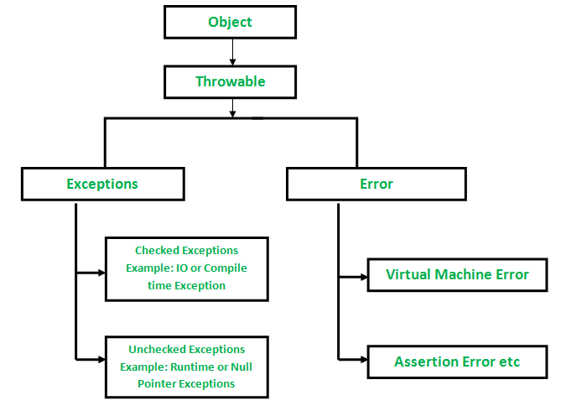

# Built-in Exceptions

Java defines several exception classes inside the standard package **java.lang**. The most general of these exceptions are subclasses of the standard type RuntimeException. Since java.lang is implicitly imported into all Java programs, most exceptions derived from RuntimeException are automatically available.

Java defines several other types of exceptions that relate to its various class libraries. Following is the list of Java Unchecked RuntimeException.

|  |  |  |
| --- | --- | --- |
| **S.No.** | **Exception** | **Description** |
| 1 | **ArithmeticException** | Arithmetic error, such as divide-by-zero. |
| 2 | **ArrayIndexOutOfBoundsException** | Array index is out-of-bounds. |
| 3 | **ArrayStoreException** | Assignment to an array element of an incompatible type. |
| 4 | **ClassCastException** | Invalid cast. |
| 5 | **IllegalArgumentException** | Illegal argument used to invoke a method. |
| 6 | **IllegalStateException** | Environment or application is in incorrect state. |
| 7 | **IllegalThreadStateException** | Requested operation not compatible with the current thread state. |
| 8 | **IndexOutOfBoundsException** | Some type of index is out-of-bounds. |
| 9 | **NegativeArraySizeException** | Array created with a negative size. |
| 10 | **NullPointerException** | Invalid use of a null reference. |
| 11 | **NumberFormatException** | Invalid conversion of a string to a numeric format. |
| 12 | **StringIndexOutOfBounds** | Attempt to index outside the bounds of a string. |

Following is the list of Java **Checked Exceptions** Defined in java.lang.

|  |  |  |
| --- | --- | --- |
| **S.No.** | **Exception** | **Description** |
| 1 | **ClassNotFoundException** | Class not found. |
| 2 | **CloneNotSupportedException** | Attempt to clone an object that does not implement the Cloneable interface. |
| 3 | **IllegalAccessException** | Access to a class is denied. |
| 4 | **InstantiationException** | Attempt to create an object of an abstract class or interface. |
| 5 | **InterruptedException** | One thread has been interrupted by another thread. |
| 6 | **NoSuchFieldException** | A requested field does not exist. |
| 7 | **NoSuchMethodException** | A requested method does not exist. |

## Exception Handlers

There are 5 exception handlers in which try, catch and finally are blocks and throw and throws are the keywords.

|  |  |
| --- | --- |
| **Keyword** | **Description** |
| Try | The "try" keyword is used to specify a block where we should place exception code. The try block must be followed by either catch or finally. It means, we can't use try block alone. |
| Catch | The "catch" block is used to handle the exception. It must be preceded by try block which means we can't use catch block alone. It can be followed by finally block later. |
| Finally | The "finally" block is used to execute the important code of the program. It is executed whether an exception is handled or not. |
| Throw | The "throw" keyword is used to throw an exception. |
| Throws | The "throws" keyword is used to declare exceptions. It doesn't throw an exception. It specifies that there may occur an exception in the method. It is always used with method signature. |

**Thread**

A thread of execution is an individual process that has its own flow of control A thread is also called as a light weight process since multiple threads can share some resources among them. Each thread is associated with its own class stack.

Java Support the most powerful and useful feature called Multi-threading to execute multiple individual processes at a time simultaneously. In Multi-threading, a program is divided into two or more sub programs called processes which can be implemented at the same time.

A thread is process that has a single flow control. Each thread has a beginning, a body and an end. **The programs which have only one flow of control is called single-threaded programs** and **that having more than one flow of control are called multi-threaded programs**.

Every java program must use at least one thread to complete its execution. The main() method also runs in one thread called main thread. In main call stack, main() method is at the bottom of the stack.

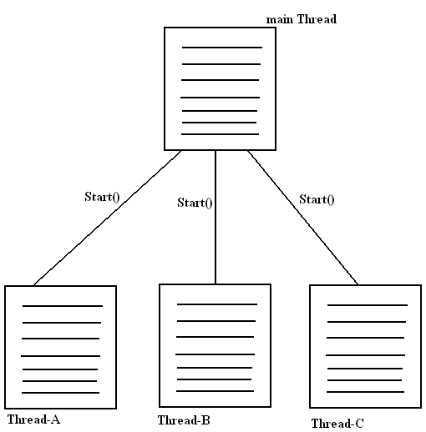

**Creating Threads:**

In java, a thread means two different things,

1. An Instance of class java.lang.Thread
2. A thread of execution

A thread in java begins as an instance of java.lang.Thread. Creating threads in java is simple. Threads are implemented in the form of objects that contain a method called run(). The code which we want to execute in a separate thread must be placed in the run() method. The thread of execution always begins by invoking the run() method.

In java, we can define and instantiate a new thread in two different ways,

1. Defining a class that extends Thread class
2. Defining a class that implements runnable interface.

**Extending the thread class:**

In this methods, we define a class that extends the java.lang.Thread class and override the run() method. This is the simplest way of defining code to run in a separate thread. This gives us access to all the thread methods directly. This method includes the following steps.

1. Declare a class as extending java.lang.Thread class
2. Override the run() method by placing the code of the process
3. Create an object to the newly defined class
4. Call the start() method to invoke the thread for execution.

**Syntax:** class class_name extends Thread

{

public static void main(String[] args) throws Exception

{

Thread t1=new class_name();

Thread t2=new class_name();

t1.start();

t2.start();

}

public void run()

{

if(Thread1)

{

Statement1;

Statement2;

}

if(thread2)

{ Statement1;

Statement2;

}

}

}

**Implements runnable interface**

In this method, we define a class that implements the Runnable interface and implement the run() method which belongs to Runnable interface. This method gives the advantage when compared to method-1 that is we can extend our thread lass to any other class. It includes the following steps.

1. Declare a class that implements Runnable interface
2. Implement the run() method
3. Create Thread object and attach the Runnable class to it.
4. Call the start() method to invoke the thread for execution.

**Syntax:**

class class_name implements Runnable

{

public static void main(String[] args) throws Exception

{

Runnable r=new syntest();

Thread t1=new class_name(r);

Thread t2=new class_name(r);

t1.start();

t2.start();

t1.join();

t2.join();

}

public void run()

{

if(Thread1)

{

Statement1;

Statement2;

}

if(thread2)

{

Statement1;

Statement2;

}

}

}

**Life cycle of threads**

Thread can be defined as a sequence of instructions which can run independently. Threads can share data among other threads. Threads concept is the origin of multi-user systems. A program can be made executed quickly by dividing the program instructions into groups called threads. Each thread has a life cycle. In its life cycle the thread has five states. They are,

* + - * 1. Born state
        2. Runnable state
        3. Running state
        4. Blocked state
        5. Dead state

**Born State:**

When we create a thread object, the thread is born and is said to be in newborn state. The thread is not yet scheduled for running. At this state, we can do only one of the following things with it.

* + 1. Schedule it for running using start() method
    2. Kill it using stop() method

If scheduled, it moves to the runnable state. If we attempt to use any other method at this stage, an exception will be thrown(interruptedException).

**Runnable state:**

If a thread is ready for execution and if the thread is waiting for the availability of processor then the thread is said to be in runnable state. In this state, the threads which are waiting for the availability of processor form a queue and whenever a thread gets processor it becomes active and moves to the running state. All the threads waiting in the queue have their own priorities. The thread with highest priority will go to the running state first. If the priorities of all threads are equal then the threads are equal then the threads are activated to first come first served fashion.

**Running state:**

A thread is said to be in running state if it is being executed i.e., when a processor is being allotted to the thread. A running thread may relinquish from control on its own or it relinquishes when it is being preempted by a high priority thread. A running thread may relinquishes from control for three reasons,

1. When a thread is being suspended using **suspend()** method, it moves from running state to blocked stated. The blocked thread can be renewed using **resume()** method.
2. When a thread is made to sleep using **sleep(n)**. The thread gets blocked for given milliseconds.
3. When a thread is asleep to **wait()** method, the thread gets blocked and the thread can be renewed using **notify()** method.

**Blocked State:**

A thread is said to be blocked when, it is prevented from entering into the runnable state and subsequently the running state. This happens when the thread is suspended, sleeping or waiting in order to satisfy certain requirements. A blocked thread is considered “not runnable” but not dead and therefore fully qualified to run again.

**Dead State:**

This is the final state in the life cycle of a thread. A running thread ends its life when it has completed executing its run() method, it is a natural death. However, we can kill it by sending the stop() method at any state thus causing a premature death to it. A thread can be killed as soon as it is born or while it is running, or even when it is in “not runnable” condition.

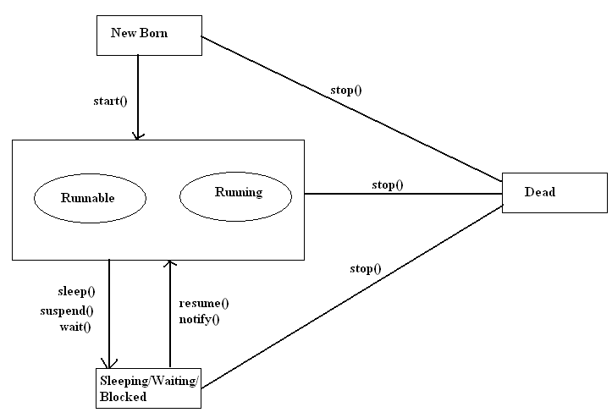

**Thread Information**

Every thread carries properties along with it. They are **Thread Name, Thread Priority and Thread Group Name**

Two or more threads can be grouped with help of a thread group, to execute functionality collectively. By default all the child threads created in main thread are placed under main thread group. **Default priority** of main thread is **5** which is known as “**Normal Priority**”. By default child thread acquires the same priority as that of parent thread.

Priority for a thread can be set between1 to 10 any number. **1 is minimum priority,10 is maximum priority** and **5 is Normal Priority**. To support these values thread has static final variables. They are –

1. Thread.MIN_PRIORITY -1
2. Thread.NORM_PRIORITY – 5
3. Thread.MAX_PRIORITY – 10

**Methods:**

1. setPriority() is a method from thread class to change the priority of a thread.
2. **getPriority()** is a method to get the priority of a thread
3. **setName()** is a method to set the name for the thread
4. **getName()** is a method to get the name of the thread
5. **getThreadGroup()** is a method to get the name of the thread group

**Thread class methods**

Thread class provides various static methods that are as follows:

1. **currentThread():**

The currentThread() returns the reference of currently executing thread. Since this is a static method, so we can call it directly using the class name. The general syntax for currentThread() is as follows:

**Syn:**public static Thread currentThread()

1. **sleep():**

The sleep() method puts currently executing thread to sleep for specified number of milliseconds. This method is used to pause the current thread for specified amount of time in milliseconds.

Since this method is static, so we can access it through Thread class name. The general syntax of this method is as follows:

**Syn:**

public static void sleep(long milliseconds) throws InterruptedException

public static void sleep(long mseconds, int nseconds ) throw InterruptedException

1. **yield():**

The yield() method pauses the execution of current thread and allows another thread of equal or higher priority that are waiting to execute. Currently executing thread give up the control of the CPU. The general form of yield() method is as follows:

**Syn:**public static void yield()

1. **activeCount():**

This method returns the number of active threads.

**Syn:**public static int activeCount()